**Introduction to TensorFlow for Artificial Intelligence, Machine Learning, and Deep Learning**

#### A primer in machine learning

* Coding has been the bread and butter for developers since the dawn of computing.
* We're used to creating applications by breaking down requirements into composable problems that can then be coded against.
* So for example, if we have to write an application that figures out a stock analytic, maybe the price divided by the ratio, we can usually write code to get the values from a data source, do the calculation and then return the result.

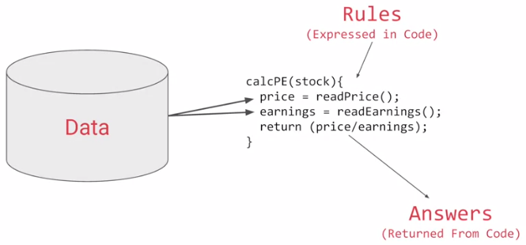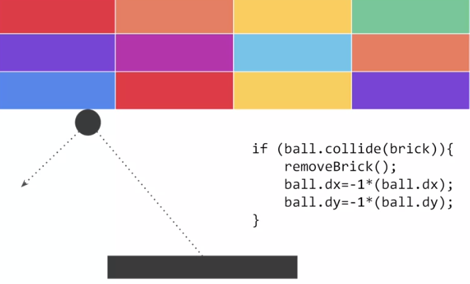

* Or if we're writing a game we can usually figure out the rules.
* For example, if the ball hits the brick then the brick should vanish and the ball should rebound.
* But if the ball falls off the bottom of the screen then maybe the player loses their life.
* We can represent that with this diagram.

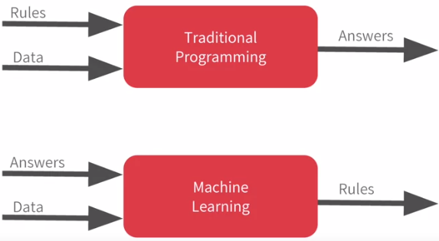

* Rules and data go in answers come out.
* Rules are expressed in a programming language and data can come from a variety of sources from local variables all the way up to databases.
* Machine learning rearranges this diagram where we put answers in data in and then we get rules out.
* So instead of us as developers figuring out the rules when should the brick be removed, when should the player's life end, or what's the desired analytic for any other concept, what we will do is we can get a bunch of examples for what we want to see and then have the computer figure out the rules.
* Now, this is particularly valuable for problems that you can't solve by figuring the rules out for yourself.

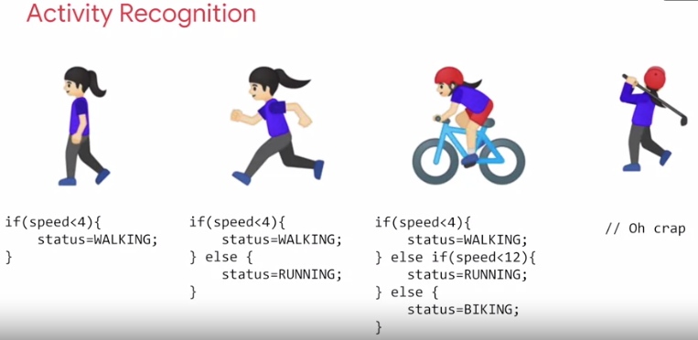

* So consider this example, activity recognition.
* If I'm building a device that detects if somebody is say walking and I have data about their speed, I might write code like this and if they're running well that's a faster speed so I could adapt my code to this and if they're biking, well that's not too bad either.
* I can adapt my code like this.
* But then I have to do golf recognition too, now my concept becomes broken.
* But not only is that, doing it by speed alone of course quite naive.
* We walk and run at different speeds uphill and downhill and other people walk and run at different speeds to us.
* Ultimately machine learning is very similar but we're just flipping the axes.
* So instead of me trying to express the problem as rules when often that isn't even possible, I'll have to compromise.
* The new paradigm is that I get lots and lots of examples and then I have labels on those examples and I use the data to say this is what walking looks like, this is what running looks like, this is what biking looks like and yes, and even this is what golfing looks like.
* So, then it becomes answers and data in with rules being inferred by the machine.

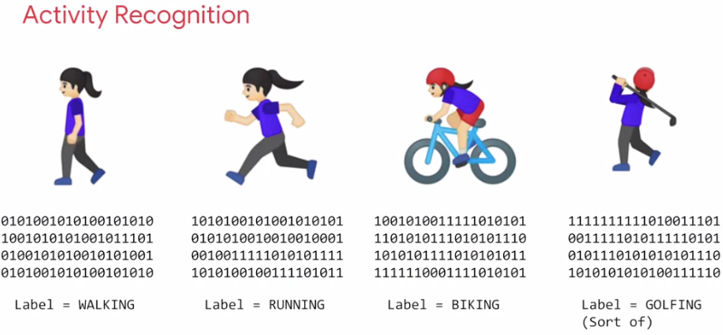

* A machine learning algorithm then figures out the specific patterns in each set of data that determines the distinctiveness of each.
* That's what's so powerful and exciting about this programming paradigm.
* It opens up new possibilities that were infeasible to do before.
* *A neural network is just a slightly more advanced implementation of machine learning and we call that deep learning.*
* But fortunately it's actually very easy to code.

#### The ‘Hello World’ of neural networks

* Earlier we mentioned that machine learning is all about a computer learning the patterns that distinguish things.
* Like for activity recognition, it was the pattern of walking, running and biking that can be learned from various sensors on a device.
* To show how that works, let's take a look at a set of numbers and see if you can determine the pattern between them.
* Okay, here are the numbers. X = [-1, 0 , 1, 2, 3, 4] and Y = [-3, -1, 1, 3, 5, 7].
* There's a formula that maps X to Y. Can you spot it? Take a moment.
* Well, the answer is Y equals 2X minus 1.
* So whenever you see a Y, it's twice the corresponding X minus 1.
* If you figured it out for yourself, well done, but how did you do that? How would you think you could figure this out? Maybe you can see that the Y increases by 2 every time the X increases by 1.
* So it probably looks like Y equals 2X plus or minus something.
* Then when you saw X equals 0 and Y equals minus 1, so you thought hey that the something is a minus 1, so the answer might be Y = 2X - 1.
* You probably tried that out with a couple of other values and see that it fits.
* Congratulations, you've just done the basics of machine learning in your head.

**Model = keras.Sequential([keras.layers.Dense(units = 1, input\_shape = [1])])**

* Here's our first line of code.
* This is written using Python and TensorFlow and an *API in TensorFlow called* *keras*.
* *Keras makes it really easy to define neural networks.*
* *A neural network is basically a set of functions which can learn patterns.*
* The simplest possible neural network is one that has only one neuron in it, and that's what this line of code does.
* In keras, you use the word *dense to define a layer of connected neurons.*
* There's only one dense here.
* So there's only one layer and there's only one unit in it, so it's a single neuron.
* *Successive layers are defined in sequence, hence the word sequential.*
* You define the shape of what's input to the neural network in the first and in this case the only layer and you can see that our input shape is super simple. It's just one value.
* You've probably seen that for machine learning, you need to know and use a lot of math, calculus probability and the like.
* It's really good to understand that as you want to optimize your models but the nice thing for now about TensorFlow and keras is that a lot of that math is implemented for you in functions.

**Model.compile(optimizer = ‘sgd’, loss = ‘mean\_squared\_error’)**

* There are two function roles that you should be aware of though and these are loss functions and optimizers.
* The neural network has no idea of the relationship between X and Y, so it makes a guess.
* Say it guesses Y equals 10X minus 10.
* It will then use the data that it knows about, that's the set of X’s and Y’s that we've already seen to measure *how good or how bad its guess was*.
* *The loss function measures this and then gives the data to the optimizer which figures out the next guess.*
* *So the optimizer thinks about how good or how badly the guess was done using the data from the loss function.*
* *Then the logic is that each guess should be better than the one before.*
* As the guesses get better and better, accuracy approaches 100%, the term *convergence* is used.
* In this case, the *loss is mean squared error and the optimizer is SGD which stands for stochastic gradient descent.*

(Stochastic gradient descent refers to calculating the derivative from each training data instance and calculating the update immediately. Stochastic gradient descent - updating one example at a time. Taking one example, looking at the slope, and trying to move downwards)

* *Loss function and the Optimizer help the neural network guess the pattern, measure how well or how badly the guess performed, before trying again on the next epoch, and slowly getting more accurate*.
* Our next step is to represent the known data.

**xs = np.array([-1, 0 , 1, 2, 3, 4], dtype =float)**

**ys = np.array([-3, -1, 1, 3, 5, 7, dtype = float)**

* The np.array is using a Python library called numpy that makes data representation particularly enlists much easier.
* The training takes place in the fit command.

**Model.fit(xs, ys, epochs = 500)**

* Here we're asking the model to figure out how to fit the X values to the Y values.
* The *epochs equals 500 value means that it will go through the training loop 500 times.*
* This training loop is what we described earlier.
* *Make a guess, measure how good or how bad the guesses with the loss function, then use the optimizer and the data to make another guess and repeat this.*
* When the model has finished training, it will then give you back values using the predict method.

**Print(model.predict([10.0])**

* So it hasn't previously seen 10, and what do you think it will return when you pass it a 10?
* Now you might think it would return 19 because after all Y = 2X - 1, and you think it should be 19.
* But it will return a value very close to 19 but not exactly 19. Now why do you think that would be?
* Ultimately there are two main reasons.
* The first is that you trained it using very little data.
* There's only six points. Those six points are linear but there's no guarantee that for every X, the relationship will be Y = 2X - 1.
* There's a very high probability that Y = 19, for X = 10, but the neural network isn't positive.
* So it will figure out a realistic value for Y.
* That's the second main reason.
* When using neural networks, as they try to figure out the answers for everything, they deal in probability.
* You'll see that a lot and you'll have to adjust how you handle answers to fit.

#### An Introduction to computer vision

*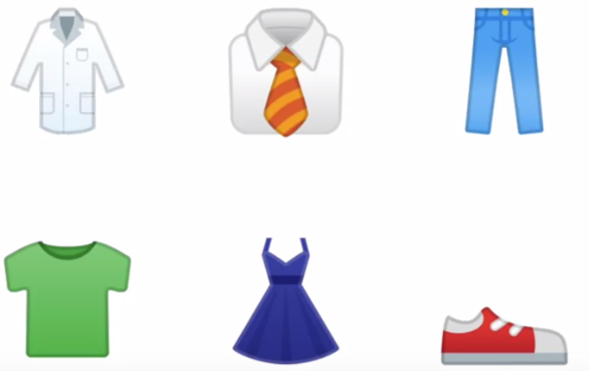*

* *Computer vision is the field of having a computer understand and label what is present in an image.*
* So one way to solve that is to use lots of pictures of clothing and tell the computer what that's a picture of and then have the computer figure out the patterns that give you the difference between a shoe, and a shirt, and a handbag, and a coat.
* Fortunately, there's a data set called Fashion MNIST which gives a 70 thousand images spread across 10 different items of clothing.
* These images have been scaled down to 28 by 28 pixels.
* *Now usually, the smaller the better because the computer has less processing to do*.
* But of course, you need to retain enough information to be sure that the features and the object can still be distinguished.
* So this size does seem to be ideal, and it makes it great for training a neural network.
* The images are also in grey scale, so the amount of information is also reduced.
* Each pixel can be represented in values from 0 to 255 and so it's only one byte per pixel.
* With 28 by 28 pixels in an image, only 784 bytes are needed to store the entire image.

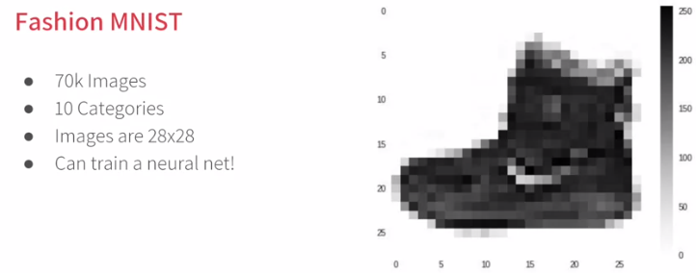

* Despite that, we can still see what's in the image and in this case, it's an ankle boot, right?

#### Writing code to load training data

**fashion\_mnist = keras.datasets.fashion\_mnist**

**(train\_images, train\_labels), (test\_images, test\_labels) = fashion\_mnist.load\_data()**

* Fortunately, it's still quite simple because Fashion-MNIST is available as a data set with an API call in TensorFlow.
* We simply declare an object of type MNIST loading it from the Keras database.
* On this object, if we call the load data method, it will return four lists to us.
* That's the training data, the training labels, the testing data, and the testing labels.
* Now, what are these you might ask?
* Well, when building a neural network like this, it's a nice strategy to use some of your data to train the neural network and similar data that the model hasn't yet seen to test how good it is at recognizing the images.
* So in the Fashion-MNIST data set, 60,000 of the 70,000 images are used to train the network, and then 10,000 images, one that it hasn't previously seen, can be used to test just how good or how bad it is performing.
* So this code will give you those sets.

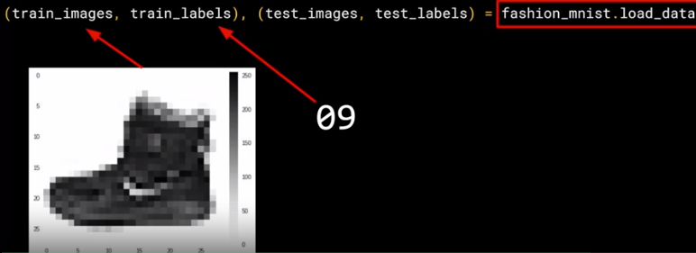

* Then, each set has data, the images themselves and labels and that's what the image is actually of.
* So for example, the training data will contain images like this one, and a label that describes the image like this.

* While this image is an ankle boot, the label describing it is the number nine.
* Now, why do you think that might be?
* There are two main reasons.
  + First, of course, is that computer’s do better with numbers than they do with texts.
  + Second, importantly, is that this is something that can help us reduce bias.
* If we labelled it as an ankle boot, we would be of course biasing towards English speakers.
* But with it being a numeric label, we can then refer to it in our appropriate language be it English, Hindi, Chinese, Japanese, or here, even Irish Gaelic.
* Using a number is a first step in avoiding bias -- instead of labelling it with words in a specific language and excluding people who don’t speak that language! You can learn more about bias and techniques to avoid it [here](https://developers.google.com/machine-learning/fairness-overview/).

#### Coding a Computer Vision Neural Network

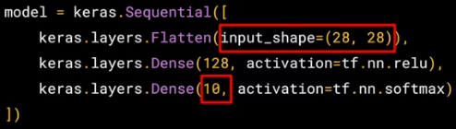

* Now we have three layers.
* The important things to look at are the first and the last layers.
* *The last layer has 10 neurons in it because we have ten classes of clothing in the dataset.*

\*\*\*They should always match\*\*\*

* *The first layer is a flatten layer with the input shaping 28 by 28.*
* Now, if you remember our images are 28 by 28, so we're specifying that this is the shape that we should expect the data to be in.
* *Flatten takes this 28 by 28 square and turns it into a simple linear array.*

* *The interesting stuff happens in the middle layer, sometimes also called a hidden layer.*

*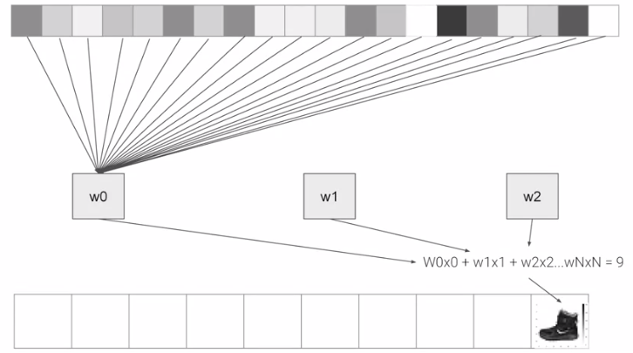*

* There are 128 neurons in it, and think about these as variables in a function. Maybe call them x1, x2 x3, etc.
* Now, there exists a rule that incorporates all of these that turns the 784 values of an ankle boot into the value nine, and similar for all of the other 70,000.
* It's too complex a function for you to see by mapping the images yourself, but that's what a neural net does.
* So, for example, if you then say the function was y = w1 \* x1 + w2 \* x2 + w3 \* x3, all the way up to a w128 \* x128.
* By figuring out the values of w, then y will be nine, when you have the input value of the shoe.
* You'll see that it's doing something very, very similar to what we did earlier when we figured out y = 2x - 1.
* In that case the 2, was the weight of x.
* So, I'm saying y = w1 \* x1, etc.
* You can also tune the neural network by adding, removing and changing layer size to see the impact.
* Also, if you want to go further, checkout this tutorial from Andrew on YouTube, which will clarify how dense connected layer's work from the theoretical and mathematical perspective.

#### Using Callbacks to control training

* When experimenting with different numbers of epochs , how to stop the training when after reaching a particular point? Should I’ve to always hard code it to go for certain number of epochs?
* Well, the good news is that, the training loop does support callbacks.
* So in every epoch, you can callback to a code function, having checked the metrics.
* Here's our code for training the neural network to recognize the fashion images.
* What we'll now do is write a callback in Python. Here's the code.

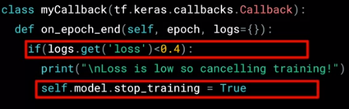

* It's implemented as a separate class, but that can be in-line with other code. It doesn't need to be in a separate file.
* In it, the **on\_epoch\_end** function, this gets called by the callback whenever the epoch ends.
* *It also sends a logs object which contains lots of great information about the current state of training.*
* For example, the current loss is available in the logs, so we can query it for certain amount.
* For example, here if the loss is less than 0.4 and cancelling the training itself.
* There are two modifications that we need to make in main code.

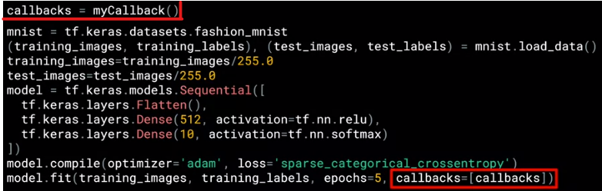

* First, instantiate the class that was just created.
* Then, in model.fit, use the callbacks parameter and pass it this instance of the class.

#### What are convolutions and pooling?

* In the previous example, you saw how you could create a neural network called a deep neural network to pattern match a set of images of fashion items to labels.
* In just a couple of minutes, you're able to train it to classify with pretty high accuracy on the training set, but a little less on the test set.
* Now, one of the things that you would have seen when you looked at the images is that there's a lot of wasted space in each image.
* While there are only 784 pixels, it will be interesting to see if there was a way that we could condense the image down to the important features that distinguish what makes it a shoe, or a handbag, or a shirt.
* That's where convolutions come in.
* *Image processing usually involves having a filter and passing that filter over the image in order to change the underlying image.*

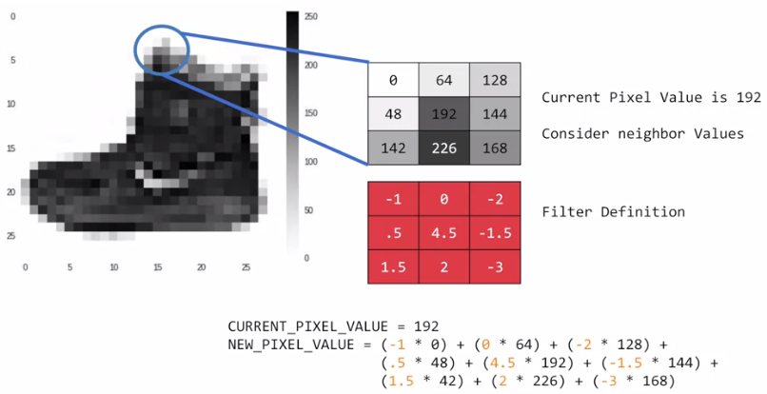

* The process works a little bit like this.
* For every pixel, take its value, and take a look at the value of its neighbours.
* If our filter is three by three, then we can take a look at the immediate neighbour, so that you have a corresponding three by three grid.
* Then to get the new value for the pixel, we simply multiply each neighbour by the corresponding value in the filter.
* So, for example, in this case, our pixel has the value 192, and its upper left neighbour has the value 0.
* The upper left value and the filter is negative one, so we multiply zero by negative one.
* Then we would do the same for the upper neighbour.
* Its value is 64 and the corresponding filter value was 0, so we'd multiply those out.
* Repeat this for each neighbour and each corresponding filter value, and would then have the *new pixel with the sum of each of the neighbour values multiplied by the corresponding filter value, and that's a convolution.*
* *The operation where you take the sum of products of elements from two 2D functions, where you let one of the two functions move over every element of the other function, is called Convolution or Correlation.*
* *In simple terms convolution is technique to isolate features in an image*.
* The idea here is that some convolutions will change the image in such a way that certain features in the image get emphasized.

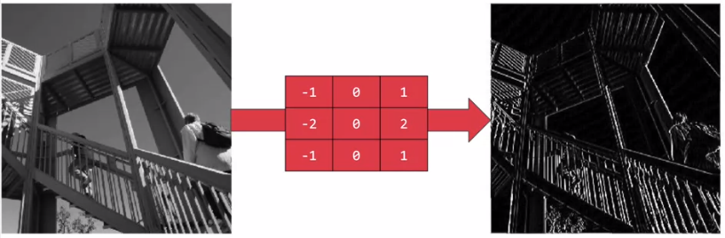

* So, for example, if you look at this filter, then the vertical lines in the image really pop out.

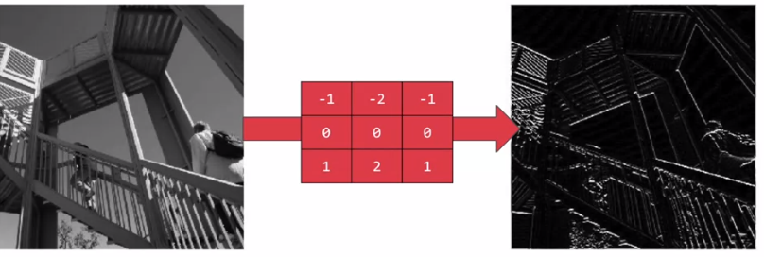

* With this filter, the horizontal lines pop out.
* *Now, that's a very basic introduction to what convolutions do, and when combined with something called pooling, they can become really powerful.*
* *Pooling is a technique to reduce information in an image while maintaining features in a image.*
* But simply, *pooling is a way of compressing an image.*
* A quick and easy way to do this, is to go over the image of four pixels at a time, i.e, the current pixel and its neighbours underneath and to the right of it.
* Of these four, pick the biggest value and keep just that.

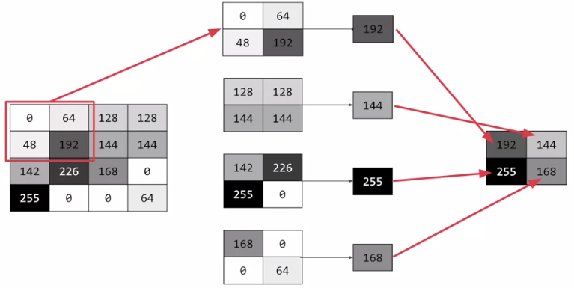

* For example, here 16 pixels on the left are turned into the four pixels on the right, by looking at them in two-by-two grids and picking the biggest value.
* This will preserve the features that were highlighted by the convolution, while simultaneously quartering the size of the image.
* We have the horizontal and vertical axes.

#### Implementing convolutional layers

* So now let's take a look at convolutions and pooling in code.
* We don't have to do the entire math for filtering and compressing, we simply define convolutional and pooling layers to do the job for us.

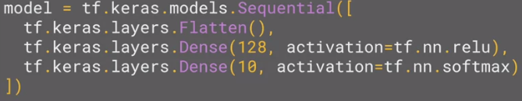

* So here's our code from the earlier example, where we defined out a neural network to have an input layer in the shape of our data, and output layer in the shape of the number of categories we're trying to define, and a hidden layer in the middle.
* The Flatten takes our square 28 by 28 images and turns them into a one dimensional array.
* To add convolutions to this, you use code like this.

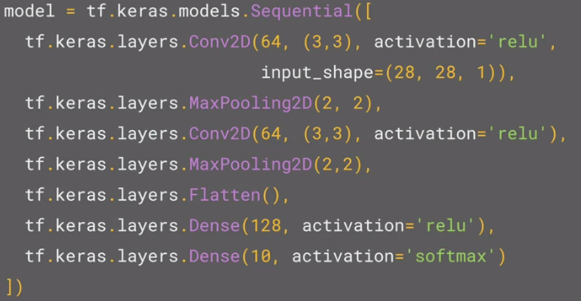

* You'll see that the last three lines are the same, the Flatten, the Dense hidden layer with 128 neurons, and the Dense output layer with 10 neurons.
* What's different is what has been added on top of this.

**( tf.keras.layers.Conv2D(64, (3, 3), activation = ‘relu’, input\_shape = (28, 28, 1)), )**

* Here we're specifying the first convolution.
* We're asking keras to generate 64 filters for us.
* These filters are 3 by 3, their activation is relu, which means the negative values will be thrown way, and finally the input shape is as before, the 28 by 28.
* That extra 1 just means that we are tallying using a single byte for colour depth.
* As we saw before our image is our grey scale, so we just use one byte.
* Now, of course, you might wonder what the 64 filters are.
* It's a little beyond the scope of this class to define them, but they aren't random.
* They start with a set of known good filters in a similar way to the pattern fitting that you saw earlier, and the ones that work from that set are learned over time.

You’ve seen how to add a convolutional 2d layer to the top of your neural network. To know more on how they work, check out the playlist at <https://bit.ly/2UGa7uH>.)

#### Implementing pooling layers

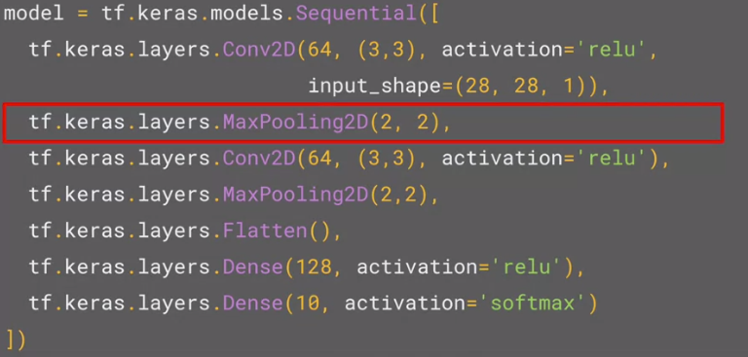

* This next line of code will then create a pooling layer.
* It's max-pooling because we're going to take the maximum value.
* We're saying it's a two-by-two pool, so for every four pixels, the biggest one will survive.
* We then add another convolutional layer, and another max-pooling layer so that the network can learn another set of convolutions on top of the existing one, and then again, pool to reduce the size.
* So, by the time the image gets to the flatten to go into the dense layers, it's already much smaller.
* It's being quartered, and then quartered again.
* So, its content has been greatly simplified, the goal being that the convolutions will filter it to the features that determine the output.

**model.summary()**

* A really useful method on the model is the model.summary method.
* This allows you to inspect the layers of the model, and see the journey of the image through the convolutions, and here is the output.

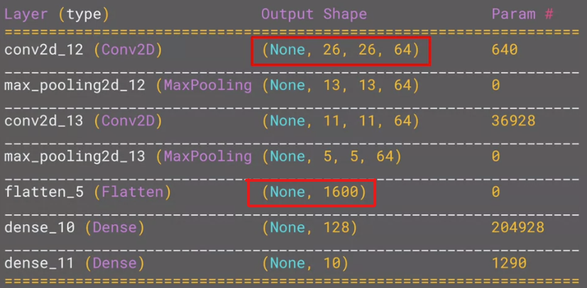

* It's a nice table showing us the layers, and some details about them including the output shape.
* It's important to keep an eye on the output shape column. (None, 26, 26, 64)
* When you first look at this, it can be a little bit confusing and feel like a bug.
* After all, isn't the data 28 by 28, so why is the output, 26 by 26?
* The key to this is remembering that the filter is a three by three filter.
* Consider what happens when you start scanning through an image starting on the top left.

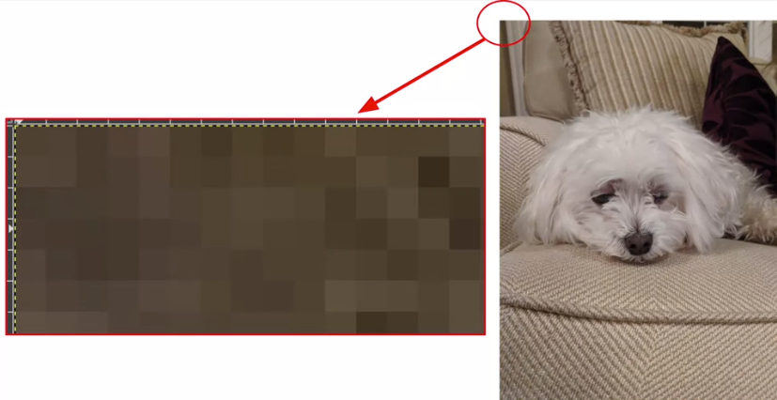

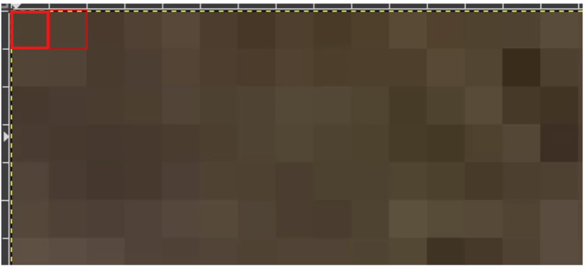 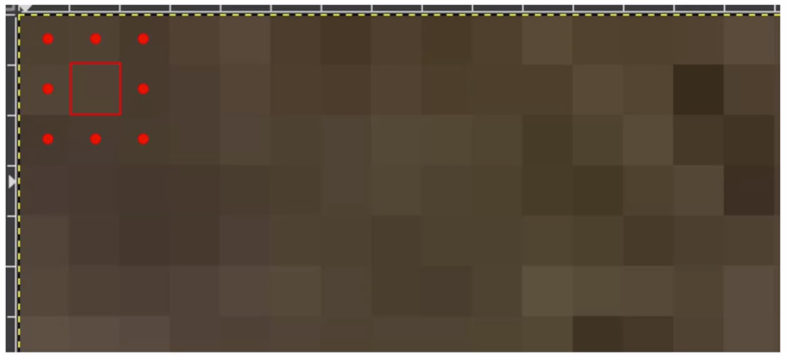

* So, for example with this image of the dog on the right, you can see zoomed into the pixels at its top left corner.
* You can't calculate the filter for the pixel in the top left, because it doesn't have any neighbours above it or to its left.
* In a similar fashion, the next pixel to the right won't work either because it doesn't have any neighbours above it.
* So, logically, the first pixel that you can do calculations on is this one, because this one of course has all eight neighbours that a three by three filter needs.
* This when you think about it, means that you can't use a one pixel margin all around the image, so the output of the convolution will be two pixels smaller on x, and two pixels smaller on y.
* If your filter is five-by-five for similar reasons, your output will be four smaller on x, and four smaller on y.
* So, that's why with a three by three filter, our output from the 28 by 28 image, is now 26 by 26, we've removed that one pixel on x and y, and each of the borders.
* So, next is the first of the max-pooling layers.
* Now, remember we specified it to be two-by-two, thus turning four pixels into one, and having our x and y.
* So, now our output gets reduced from 26 by 26, to 13 by 13.
* The convolutions will then operate on that, and of course, we lose the one pixel margin as before, so we're down to 11 by 11, add another two-by-two max-pooling to have this rounding down, and went down, down to five-by-five images.
* So, now our dense neural network is the same as before, but it's being fed with five-by-five images instead of 28 by 28 ones.

* But remember, it's not just one compress five-by-five image instead of the original 28 by 28, there are a number of convolutions per image that we specified, in this case 64.
* So, there are 64 new images of five-by-five that had been fed in.
* Flatten that out and you have 25 pixels times 64, which is 1600.
* So, you can see that the new flattened layer has 1,600 elements in it, as opposed to the 784 that you had previously.
* This number is impacted by the parameters that you set when defining the convolutional 2D layers.

#### Improving the Fashion classifier with convolutions

* By passing filters over an image to reduce the amount of information, they then allowed the neural network to effectively extract features that can distinguish one class of image from another.
* Also pooling compresses the information to make it more manageable.
* This is a really nice way to improve our image recognition performance.
* In previous topic we’ve used two convolutional layers each with 64 convolution, and each followed by a max pooling layer.
* You can see that we defined our convolutions to be three-by-three and our pools to be two-by-two. Let's train.
* The first thing you'll notice is that the training is much slower.
* *For every image, 64 convolutions are being tried, and then the image is compressed and then another 64 convolutions, and then it's compressed again, and then it's passed through the DNN, and that's for 60,000 images that this is happening on each epoch.*
* The Keras API gives us each convolution and each pooling and each dense, etc. as a layer.
* So with the layers API, we can take a look at each layer's outputs, so let’s create a list of each layer's output.

(Open the notebook -  [click](https://colab.research.google.com/github/lmoroney/dlaicourse/blob/master/Course%201%20-%20Part%206%20-%20Lesson%202%20-%20Notebook.ipynb" \l "scrollTo=uRLfZ0jt-fQI))

* We can then treat each item in the layer as an individual activation model if I want to see the results of just that layer.
* Now, by looping through the layers, we can display the journey of the image through the first convolution and then the first pooling and then the second convolution and then the second pooling.
* Note how the size of the image is changing by looking at the axes.
* If we set the convolution number to one, we can see that it almost immediately detects the laces area as a common feature between the shoes.
* So, for example, if I change the third image to be one, which looks like a handbag, you'll see that it also has a bright line near the bottom that could look like the soul of the shoes, but by the time it gets through the convolutions, that's lost, and that area for the laces doesn't even show up at all.
* So this convolution definitely helps us separate issue from a handbag.

'overfitting' occurs when the network learns the data from the training set really well, but it's too specialised to only that data, and as a result it’s less effective at seeing other data. For example, if all your life you only saw red shoes, then when you see a red shoe you would be very good at identifying it, but blue suede shoes might confuse you.

#### Walking through convolutions

* In the previous lessons, you saw the impacts that convolutions and pooling had on your networks efficiency and learning, but a lot of that was theoretical in nature.

(Open the python notebook – [click](https://colab.research.google.com/github/lmoroney/dlaicourse/blob/master/Course%201%20-%20Part%206%20-%20Lesson%203%20-%20Notebook.ipynb#scrollTo=7oPhUPNhuGWC).)

* So first, we'll set up our inputs and in particular, import the misc library from SciPy.
* Now, this is a nice shortcut for us because misc.ascent returns a nice image that we can play with, and we don't have to worry about managing our own.
* Matplotlib contains the code for drawing an image and it will render it right in the browser with Colab.
* Here, we can see the ascent image from SciPy.
* Next up, we'll take a copy of the image, and we'll add it with our homemade convolutions, and we'll create variables to keep track of the x and y dimensions of the image.
* So we can see here that it's a 512 by 512 image.
* So now, let's create a convolution as a three by three array.
* We'll load it with values that are pretty good for detecting sharp edges first.
* We iterate over the image, leaving a one pixel margin.
* You'll see that the loop starts at one and not zero, and it ends at size x minus one and size y minus one.
* In the loop, it will then calculate the convolution value by looking at the pixel and its neighbours, and then by multiplying them out by the values determined by the filter, before finally summing it all up.
* After executing the code, we can see that only certain features made it through the filter.
* I've provided a couple more filters, so let's try them.
* This first one is really great at spotting vertical lines.
* So when I run it, and plot the results, we can see that the vertical lines in the image made it through.
* It's really cool because they're not just straight up and down, they are vertical in perspective within the perspective of the image itself.
* Similarly, there is a filter which works well with horizontal lines.
* So when I run it, and then plot the results, we can see that a lot of the horizontal lines made it through.

* Now, let's take a look at pooling, and in this case, Max pooling, which takes pixels in chunks of four and only passes through the biggest value.
* After executing the cod, then render the output.
* We can see that the features of the image are maintained, but look closely at the axes, and we can see that the size has been halved from the 500's to the 250's.
* For fun, we can try the other filter, run it, and then compare the convolution with its pooled version.
* Again, we can see that the features have not just been maintained, they may have also been emphasized a bit.
* So that's how convolutions work.
* Under the hood, TensorFlow is trying different filters on your image and learning which ones work when looking at the training data.
* As a result, when it works, you'll have greatly reduced information passing through the network, but because it isolates and identifies features, you can also get increased accuracy.
* Have a play with the filters in this workbook and see if you can come up with some interesting effects of your own.

#### Understanding ImageGenerator

* To this point, you built an image classifier that worked using a deep neural network and you saw how to improve its performance by adding convolutions.
* One limitation though was that it used a dataset of very uniform images.
* Images of clothing that was staged and framed in 28 by 28.
* But what happens when you use larger images and where the feature might be in different locations? For example, how about these images of horses and humans? They have different sizes and different aspect ratios.

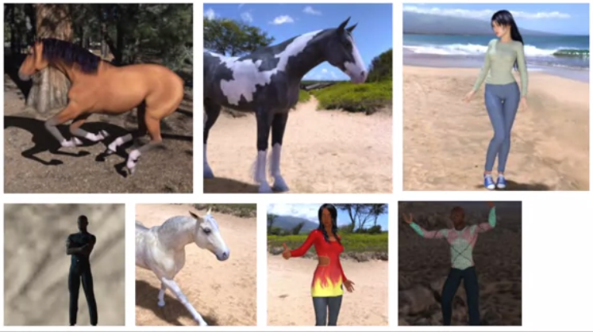

* The subject can be in different locations.
* In some cases, there may even be multiple subjects.
* In addition to that, the earlier examples with a fashion data used a built-in dataset.
* All of the data was handily split into training and test sets for you and labels were available.
* In many scenarios, that's not going to be the case and you'll have to do it for yourself.
* So in this lesson, we'll take a look at some of the APIs that are available to make that easier for you.
* In particular, the *image generator* in TensorFlow.
* *One feature of the image generator is that you can point it at a directory and then the sub-directories of that will automatically generate labels for you.*
* So for example, consider this directory structure.
* You have an images directory and in that, you have sub-directories for training and validation.
* When you put sub-directories in these for horses and humans and store the requisite images in there, the image generator can create a feeder for those images and auto label them for you.

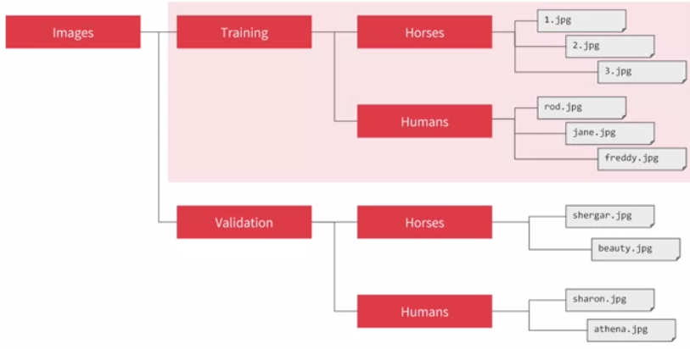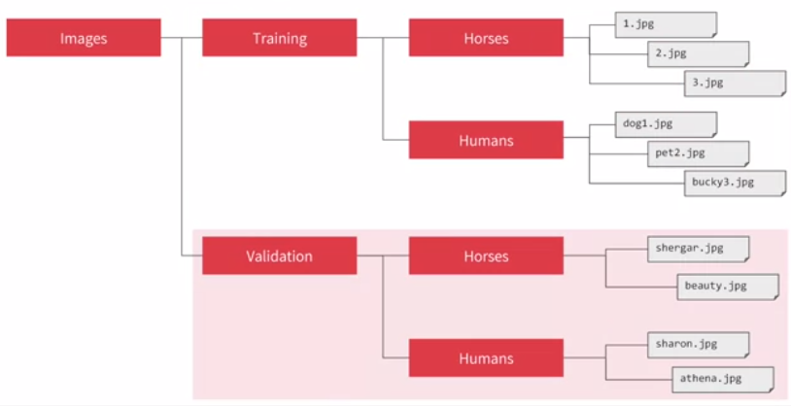

* So for example, if I point an image generator at the training directory, the labels will be horses and humans and all of the images in each directory will be loaded and labelled accordingly.
* Similarly, if I point one at the validation directory, the same thing will happen.
* So let's take a look at this in code.

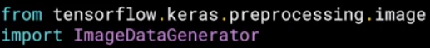

* The image generator class is available in keras.preprocessing.image.

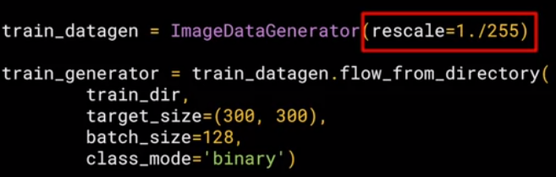

* You can then instantiate an image generator like this.
* I'm going to pass *rescale to it to normalize the data*.
* You can then call the *flow from directory* *method on it to get it to load images from that directory and its sub-directories.*
* It's a common mistake that people point the generator at the sub-directory.
* It will fail in that circumstance.
* You should always point it at the directory that contains sub-directories that contain your images.
* The names of the sub-directories will be the labels for your images that are contained within them.
* So make sure that the directory you're pointing to is the correct one.(In code, ***train\_dir***)
* Now, images might come in all shapes and sizes and unfortunately for training a neural network, the input data all has to be the same size, so the images will need to be resized to make them consistent.

***target\_size = (300, 300)***

* The nice thing about this code is that the images are resized for you as they're loaded.
* *So you don't need to preprocess thousands of images on your file system*.
* But you could have done that if you wanted to.
* *The advantage of doing it at runtime like this is that you can then experiment with different sizes without impacting your source data.*
* While the horses and humans dataset is already in 300 by 300, when you use other datasets they may not always be uniformly sized.
* So this is really useful for you.

***batch\_size = 128***

* *The images will be loaded for training and validation in batches where it's more efficient than doing it one by one.*
* Now, there's a whole science to calculating batch size that's beyond the scope of this course, but you can *experiment with different sizes to see the impact on the performance by changing this parameter.*
* Finally, there's the *class mode.*
* *Now, this is a binary classifier i.e. it picks between two different things; horses and humans,* so we specify that here.
* Other options in particular for more than two things will be explored later.

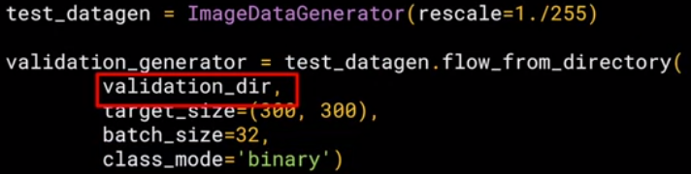

* The validation generator should be exactly the same except of course it points at a different directory, the one containing the sub-directories containing the test images.
* When you go through the workbook, you'll see how to download the images as a zip, and then sort them into training and test sub-directories, and then put horses and humans sub-directories in each.
* That's just pure Python.
* It's not TensorFlow or any other deep learning stuff.
* But it's all explained for you in the notebook.

#### Defining a ConvNet to use complex images

* So let's now take a look at the definition of the neural network that we'll use to classify horses versus humans.
* It's very similar to what you just used for the fashion items, but there are a few minor differences based on this data, and the fact that we're using generators.

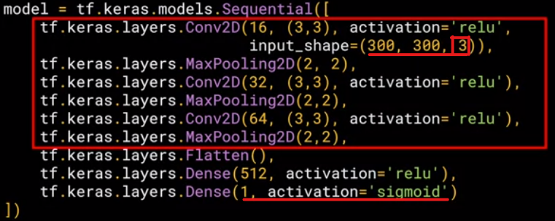

* So here's the code. As you can see, it's the sequential as before with convolutions and pooling before we get to the dense layers at the bottom.
* But let's highlight some of the differences.
* First of all, you'll notice that there are *three sets of convolution pooling layers at the top.*
* *This reflects the higher complexity and size of the images.*
* Remember our earlier our 28 by 28 halved to 13 and then five before flattening, well, now we have 300 by 300.
* So we start at 298 by 298 and then have that etc., etc. until by the end, we're at a 35 by 35 image.
* We can even add another couple of layers to this if we wanted to get to the same ballpark size as previously, but we'll keep it at three for now.
* Another thing to pay attention to is the input shape.
* *We resize their images to be 300 by 300 as they were loaded, but they're also colour images.*
* *So there are three bytes per pixel*.
* *One byte for the red, one for green, and one for the blue channel, and that's a common 24-bit colour pattern.*
* If you're paying really close attention, you can see that the output layer has also changed.
* Remember before when you created the output layer, you had one neuron per class( which led to a total of 10), but now there's only one neuron for two classes.
* That's because we're using a different activation function where *sigmoid is great for binary classification, where one class will tend towards zero and the other class tending towards one*.
* You could use two neurons here if you want, and the same softmax function as before, but for binary this is a bit more efficient.
* Now, if we take a look at our model summary, we can see the journey of the image data through the convolutions.

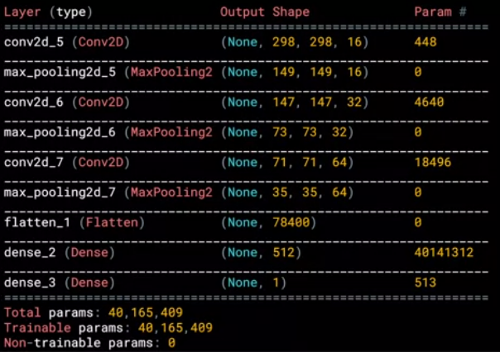

* The 300 by 300 becomes 298 by 298 after the three by three filter, it gets pulled to 149 by 149 which in turn gets reduced to 73 by 73 after the filter that then gets pulled to 35 by 35, this will then get flattened, so 64 convolutions that are 35 squared and shape will get fed into the DNN.
* If you multiply 35 by 35 by 64, you get 78,400, and that's the shape of the data once it comes out of the convolutions.
* If we had just fed raw 300 by 300 images without the convolutions, that would be over 900,000 values.
* So we've already reduced it quite a bit.

#### Training the ConvNet with fit\_generator

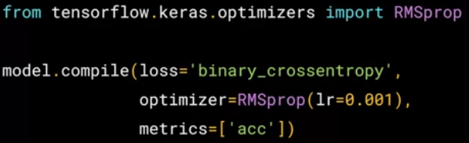

* Okay, we'll now compile the model and, as always, we have a loss function and an optimizer.
* When classifying the ten items of fashion, you might remember that your loss function was a *categorical cross entropy*.
* *But because we're doing a binary choice here, let's pick a* ***binary\_crossentropy*** *instead.*
* Also, earlier we used an Adam optimizer.
* Now, you could do that again, but I thought it would be fun to use the ***RMSprop***, *where you can adjust the learning rate to experiment with performance.*
* Okay, next up is the training, now, this looks a little different than before when you called model.fit.

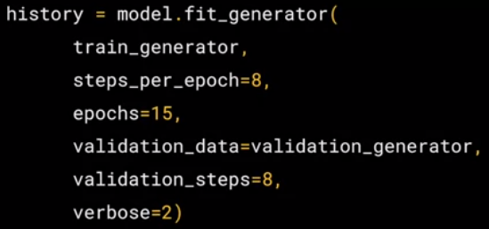

* Because now you call ***model.fit\_generator****, and that's because we're using a generator instead of datasets.*

***train\_generator***

* The first parameter is the training generator that you set up earlier. This streams the images from the training directory.
* Remember the batch size you used when you created it, it was 20, that's important in the next step.

***steps\_per\_epoch = 8***

* There are 1,024 images in the training directory, so we're loading them in 128 at a time.
* So in order to load them all, we need to do 8 batches.

***epochs = 15***

* Here we just set the number of epochs to train for.
* This is a bit more complex, so let's use, say, 15 epochs in this case.

***validation\_data = validation\_generator***

* And now we specify the validation set that comes from the validation\_generator that we also created earlier.

***validation\_steps = 8***

* It had 256 images, and we wanted to handle them in batches of 32, so we will do 8 steps.

***verbose = 2***

* *And the verbose parameter specifies how much to display while training*
* *is going on.*
* With verbose set to 2, we'll get a little less animation hiding the epoch progress.
* Once the model is trained, you will, of course, want to do some prediction on the model.

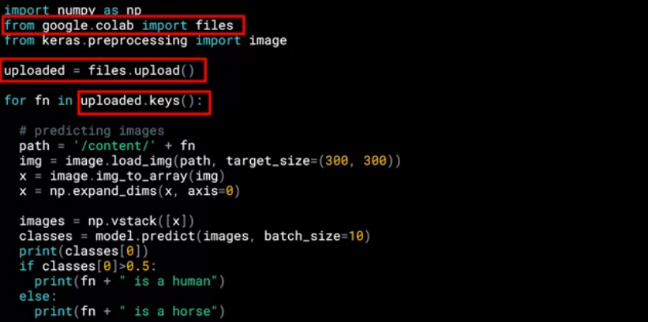

* So these parts are specific to Colab, they are what gives you the button that you can press to pick one or more images to upload.
* The image paths then get loaded into this list called uploaded.
* The loop then iterates through all of the images in that collection.
* And you can load an image and prepare it to input into the model with this code.
* Take note to ensure that the dimensions match the input dimensions that you specified when designing the model.
* You can then call model.predict, passing it the details, and it will return an array of classes.
* In the case of binary classification, this will only contain one item with a value close to 0 for one class and close to 1 for the other.
* Later you'll see multi-class classification with Softmax. Where you'll get a list of values with one value for the probability of each class and all of the probabilities adding up to 1.

## Training the neural network

Now that you’ve learned how to download and process the horses and humans dataset, you’re ready to train. When you defined the model, you saw that you were using a new loss function called ‘[Binary Crossentropy](https://gombru.github.io/2018/05/23/cross_entropy_loss/)’, and a new [optimizer](https://www.tensorflow.org/api_docs/python/tf/train/RMSPropOptimizer) called [RMSProp](http://www.cs.toronto.edu/~tijmen/csc321/slides/lecture_slides_lec6.pdf" \t "_blank). If you want to learn more about the type of binary classification we are doing here, check out [this](https://www.youtube.com/watch?v=eqEc66RFY0I&t=6s) great video from Andrew!

#### Walking through training the ConvNet with fit\_generator

(Open the notebook – [here](https://colab.sandbox.google.com/github/lmoroney/dlaicourse/blob/master/Course%201%20-%20Part%208%20-%20Lesson%202%20-%20Notebook.ipynb" \t "_blank))

* Each epoch is loading the data, calculating the convolutions and then trying to match the convolutions to labels.
* As you can see, the accuracy mostly increases but it will occasionally dip, showing the gradient ascent of the learning actually in action.
* It's always a good idea to keep an eye on fluctuations in this figure.
* And if there are too wild, you can adjust the learning rate.
* The raw pixels of the images to goes from increasingly abstract to compact representations. The representations downstream start highlighting what the network pays attention to, and they show fewer and fewer features being “activated”; most are set to zero. This is called “sparsity”. Representation sparsity is a key feature of deep learning.
* These representations carry increasingly less information about the original pixels of the image, but increasingly refined information about the class of the image. Think a convnet(or a deep network in general) as an information distillation pipeline.

#### Exploring the impact of compressing images

(Open the notebook – [here](https://colab.research.google.com/github/lmoroney/dlaicourse/blob/master/Course%201%20-%20Part%208%20-%20Lesson%204%20-%20Notebook.ipynb" \t "_blank))

* So let's take a look at what would happen if we change it to a 150 by a 150 for the images to have a quarter of the overall data and to see what the impact would be.
* Note that we've changed the input shape to be 150 by 150, and we've removed the fourth and fifth convolutional max pool combinations.
* This is a great example of the importance of measuring your training data against a large validation set, inspecting where it got it wrong and seeing what you can do to fix it.
* Using this smaller set is much cheaper to train, but then errors like this woman with her back turned and her legs obscured by the dress will happen, because we don't have that data in the training set.
* That's a nice hint about how to edit your dataset for the best effect in training.

After reducing the size of the images, the training results were different. Why?

We removed some convolution to handle the smaller images.

How did we specify the training size for the images?

The target\_size parameter on the training generator.

#### Training with the cats vs. dogs dataset

* One of the nice things with TensorFlow and Keras is that if you put your images into named subdirectories, an image generated will auto label them for you.
* So the cats and dogs dataset you could actually do that and you've already got a massive head start in building the classifier.

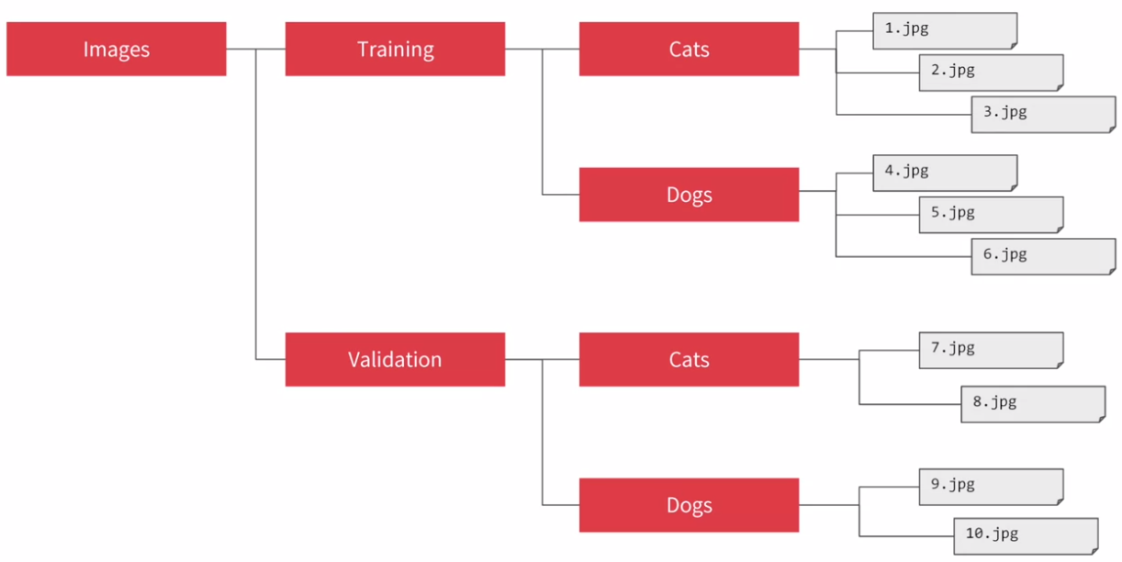

* Then you can subdivide that into a training set and a validation set.

***from tensorflow.keras.preprocessing.image import ImageDataGenerator***

* Then you can use image generators that appointed at those folders.

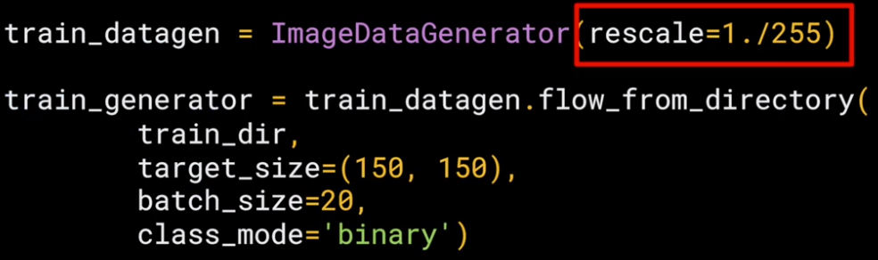

* To use an image generator, you should create an instance of one.
* If the data isn't already normalized, you can do that with the rescale parameter.
* You then call the flow from directory to get a generator object.
* For the training dataset, you will then point at the training directory and then specify the target size.
* In this case, the images are in all shapes and sizes.
* So we will resize them to 150 by 150 on the fly.
* We'll set the batch sizes to be 20.
* There are 2,000 images, so we'll use 100 batches of 20 each.
* Because there are two classes that we want to classify for its still stays as a binary class mode.

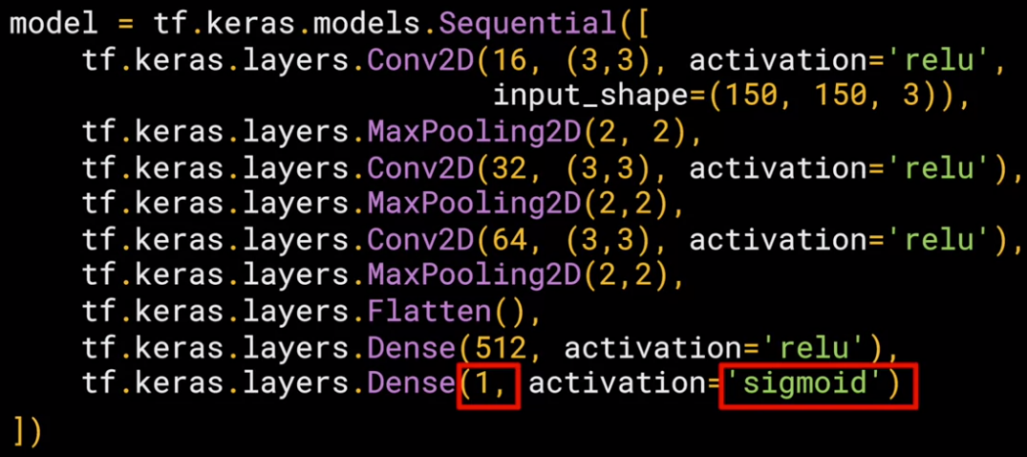

* Similarly for validation, we set up a generator and point at the validation directory.
* We can explore the convolutions and pooling and the journey of the image through them.
* It's very similar to what you saw with the horses and humans.
* It has three sets of convolutions followed by pooling.
* Similarly, there's a single neuron with a sigmoid activation on the output.
* The summary of the layers is very similar to before but note that the size changes.
* We start with 150 by 150.
* So the convolution reduces that to 148 by 148.
* From there, we'll go until we end up with 17 by 17 that we feed into the dense layers.
* Compilation is as before.

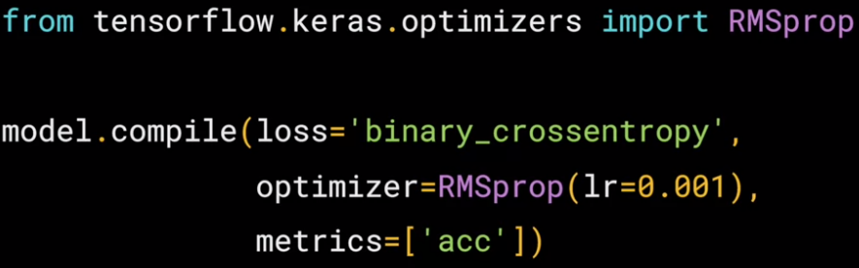

* Now remember you can tweak the learning rate by adjusting the lr parameter.

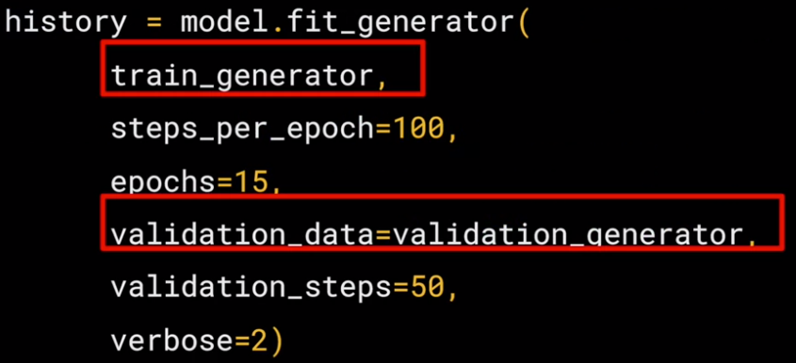

* So now to train, and we can call model.fit generator and pass it the training generator and the validation generator.

#### Visualizing the effect of the convolutions

(**Open the**[**notebook**](https://colab.sandbox.google.com/github/lmoroney/dlaicourse/blob/master/Course%202%20-%20Part%202%20-%20Lesson%202%20-%20Notebook.ipynb))

* Let's return to the notebook and take a look at the code that plots the outputs of the convolutions in max pooling layers.
* The key to this is understanding the model.layers API, which allows you to find the outputs and iterate through them, creating a visualization model for each one.
* We can then load a random image into an array and pass it to the predict method of the visualization model.
* The variable to keep an eye on is display\_grid which can be constructed from x which is read as a feature map and processed a little for visibility in the central loop.
* We'll then render each of the convolutions of the image, plus their pooling, then another convolution, etc.
* You can see images such as the dog's nose being highlighted in many of the images on the left.

#### Looking at accuracy and loss

* The object has training accuracy and loss values as well as validation accuracy and validation loss values.
* So let's iterate over these and plot them.
* Now, if you look closely, we didn't just call model.fit, we said history equals model.fit.
* So we now have a history object that we can query for data.
* Using the same history object, I'm calling its history property passing at ACC which gets me the model accuracy.
* When I run it and plot the training and validation accuracy, we can see that my training went towards one while my validation leveled out into 0.7 to 0.75 range.
* That shows that my model isn't bad, but I didn't really earn anything after just two epochs.
* It fits the training data very well with the validation data needed work.
* These results are borne out in the loss where we can see that after two epochs, my training loss went down nicely, but my validation loss climbed.
* So as it is, my model is about 75 percent accurate-ish after two epochs, and I don't really need to train any further.
* Remember also that we just used a subset of the full data.
* Using the entire dataset would likely yield better results.

## Image Augmentation

*Image Augmentation is a very simple, but very powerful tool to help you avoid overfitting your data.* The concept is very simple though: If you have limited data, then the chances of you having data to match potential future predictions is also limited, and logically, the less data you have, the less chance you have of getting accurate predictions for data that your model hasn't yet seen. To put it simply, if you are training a model to spot cats, and your model has never seen what a cat looks like when lying down, it might not recognize that in future.

Augmentation simply amends your images on-the-fly while training using transforms like rotation. So, it could 'simulate' an image of a cat lying down by rotating a 'standing' cat by 90 degrees. As such you get a cheap way of extending your dataset beyond what you have already.

To learn more about Augmentation, and the available transforms, check out <https://github.com/keras-team/keras-preprocessing> -- and note that it's referred to as **pre*processing*** for a very powerful reason: *that it doesn't require you to edit your raw images, nor does it amend them for you on-disk. It does it in-memory as it's performing the training, allowing you to experiment without impacting your dataset.*

#### Introducing augmentation

* When the dataset is small, we have relatively few examples and as a result, we can have some mistakes in our classification.
* You've probably heard us use the term overfitting a lot and it's important to understand what that is.
* Think of it as being very good at spotting something from a limited dataset, but getting confused when you see something that doesn't match your expectations.
* So for example, imagine you've seen only boots in your life.

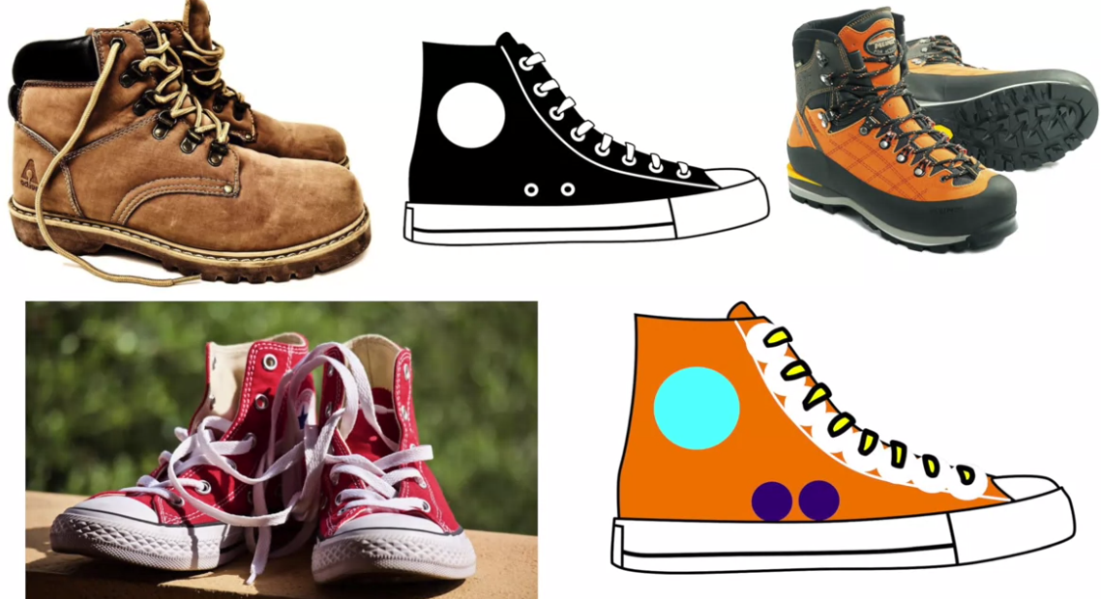

* Then, you learn that these are shoes and this is what shoes look like.
* So if I were to show you these, you would recognize them as shoes even if they are different sizes than what you would expect.

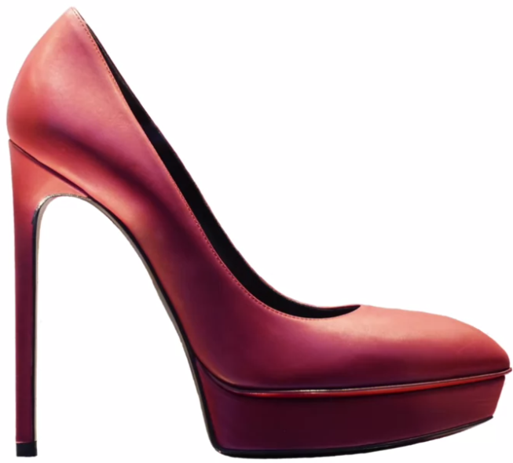

* But if I were to show you this, even though it's a shoe, you would likely not recognize it as such.
* In that scenario, you have overfit in your understanding of what a shoe looks like.
* You weren't flexible enough to see this high-heel as a shoe because all of your training and all of your experience in what shoes look like are these hiking boots.
* Now, this is a common problem in training classifiers, particularly when you have limited data.

* If you think about it, you would need an infinite dataset to build a perfect classifier, but that might take a little too long to train.
* So in this lesson, I want to look at some tools that are available to you to make your smaller datasets more effective.
* We'll start with a simple concept, augmentation.
* When using convolutional neural networks, we've been passing convolutions over an image in order to learn particular features.
* Maybe it's the pointy ears for cat, two legs instead of four for human, that kind of thing.
* Convolutions have been very good at spotting these if they're clear and distinct in the image.

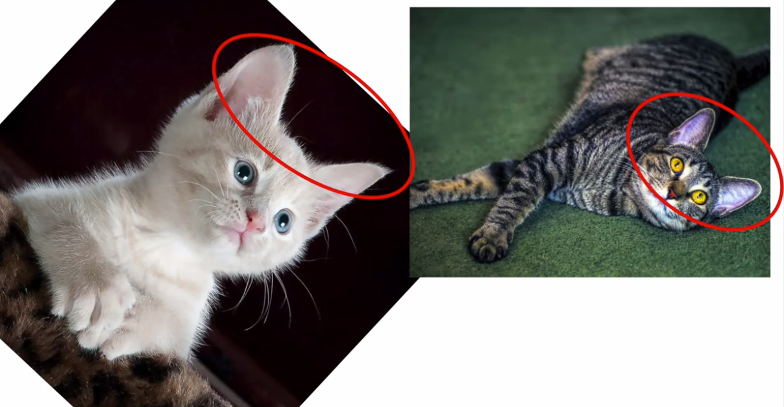

* But if we could go further, what if for example we could transform the image of the cat so that it could match other pictures of cats where the ears are oriented differently?
* So if the network was never trained for an image of a cat reclining like this, it may not recognize it.
* If you don't have the data for a cat reclining, then you could end up in an overfitting situation.
* But if your images are fed into the training with augmentation such as a rotation, the feature might then be spotted, even if you don't have a cat reclining, your upright cat when rotated, could end up looking the same.

Ok, now that we've looked at Image Augmentation implementation in Keras. You can see more about the different APIs at the Keras site here: <https://keras.io/preprocessing/image/>

#### Coding augmentation with ImageDataGenerator



* Indeed, you have already done a little image augmentation with it when you're re-scaled upon loading.
* That saved you from converting all of your images on the file system and then loading them in, you just re-scaled on the fly.
* So let's take a look at some of the other options.

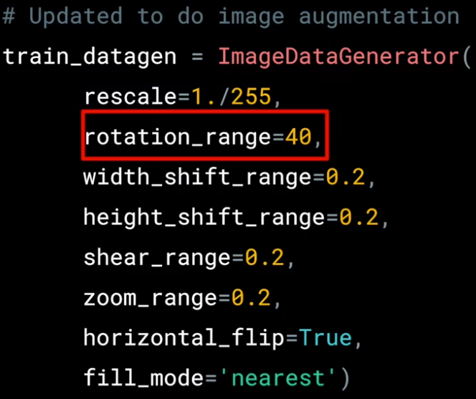

* Here's how you could use a whole bunch of image augmentation options with the image generator adding onto re-scale.
* *Rotation range is a range from 0-180 degrees with which to randomly rotate images.*
* So in this case, the image will rotate by random amount between 0 and 40 degrees.
* *Shifting, moves the image around inside its frame.*
* Many pictures have the subject centered.
* So if we train based on those kind of images, we might over-fit for that scenario.
* These parameters specify, as a proportion of the image size, how much we should randomly move the subject around.
* So in this case, we might offset it by 20% vertically or horizontally.
* *Shearing* is also quite powerful.

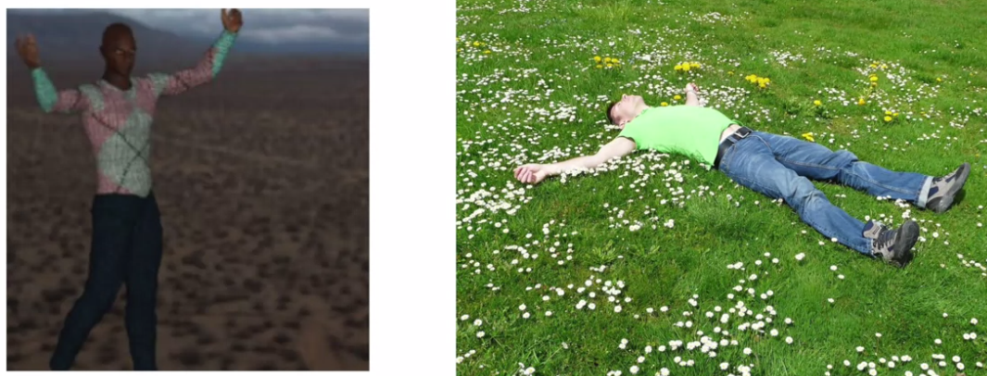 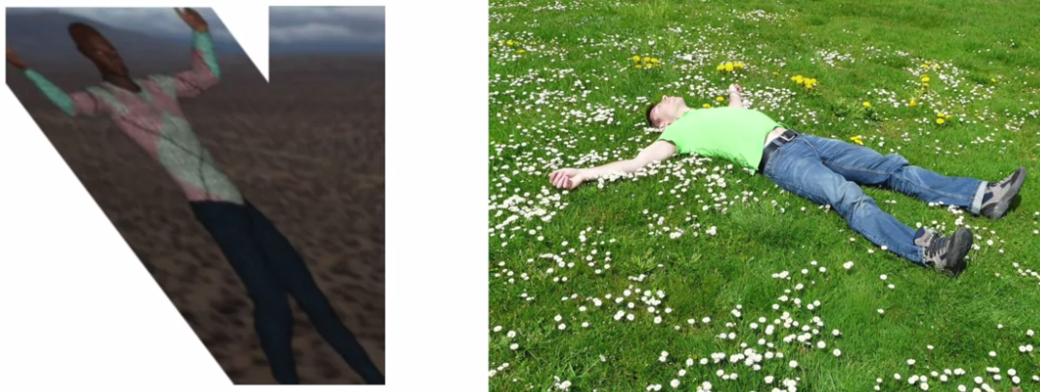

* So for example, consider the image on the right. We know that it's a person.
* But in our training set, we don't have any images of a person in that orientation.
* However, we do have an image like this one, where the person is oriented similarly.
* So if we shear that person by skewing along the x-axis, we'll end up in a similar pose.
* That's what the shear\_range parameter gives us.
* *It will shear the image by random amounts up to the specified portion in the image.*
* So in this case, it will shear up to 20 percent of the image.
* Zoom can also be very effective.

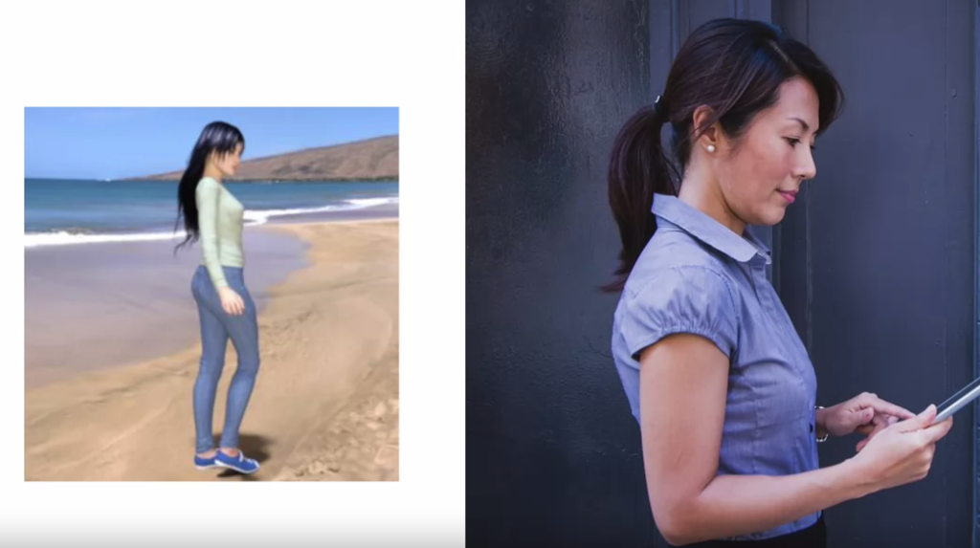

* If we zoom in on the training image, we could end up with a very similar image
* to the one on the right.
* Thus, if we zoom while training, we could spot more generalized examples like this one.
* The 0.2 is a relative portion of the image you will zoom in on.
* So in this case, zooms will be a random amount up to 20 percent of the size of the image.
* Another useful tool is *horizontal flipping*.

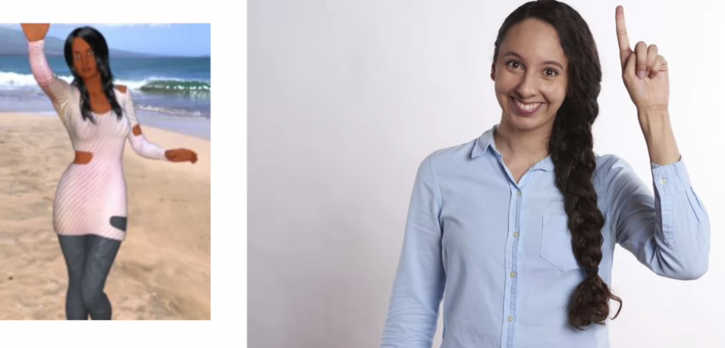

* So for example, if you consider the picture on the right, we might not be able to classify it correctly as our training data doesn't have the image of a woman with her left hand raised, it does have the image on the left, where the subjects right arm is raised.
* So if the image were flipped horizontally, then it becomes more structurally similar to the image on the right and we might not over-fit to right arm raisers.
* To turn on random horizontal flipping, you just say horizontal\_flip equals true and the images will be flipped at random.
* Finally, we just specify the *fill mode*.
* This fills in any pixels that might have been lost by the operations.
* I'm just going to stick with nearest here, which uses neighbours of that pixel to try and keep uniformity.
* Check the keras documentation for some other options.

**Having clearly seen the impact that augmentation gives to Cats v Dogs, and take a look to see if the augmentation algorithms will help there! Here’s the**[**notebook**](https://colab.research.google.com/github/lmoroney/dlaicourse/blob/master/Course%202%20-%20Part%204%20-%20Lesson%202%20-%20Notebook%20(Cats%20v%20Dogs%20Augmentation).ipynb)**if you want to try it for yourself!**

#### Exploring augmentation with horses vs. humans

* Of course, image augmentation isn't the magic bullet to cure overfitting.
* It really helps to have a massive diversity of images.
* So for example, if we look at the horses or humans data set and train it for the same epochs, then we can take a look at its behaviour.

(Open the notebook [here](https://colab.research.google.com/github/lmoroney/dlaicourse/blob/master/Course%202%20-%20Part%204%20-%20Lesson%202%20-%20Notebook%20(Cats%20v%20Dogs%20Augmentation).ipynb#scrollTo=MJPyDEzOqrKB).)

* As you watch, you'll see the test accuracy climbing steadily.
* At first, the validation accuracy seems to be in step, but then you'll see it varying wildly.
* What's happening here is that despite the image augmentation, the diversity of images is still too sparse and the validation set may also be poorly designed, namely that the type of image in it is too close to the images in the training set.
* For example, the humans are almost always standing up and in the center of the picture, in both the training and validation sets, so augmenting the image will change it to look like something that doesn't look like what's in the validation set.
* So by the time the training has completed, we can see the same pattern.
* The training accuracy is trending towards 100 percent, but the validation is fluctuating in the 60s and 70s.
* While plotting, we can see that the training accuracy climbs steadily in the way that we would want, but the validation fluctuated like crazy.
* So what we can learn from this is that the image augmentation introduces a random element to the training images but if the validation set doesn't have the same randomness, then its results can fluctuate like this.
* So bear in mind that you don't just need a broad set of images for training, you also need them for testing or the image augmentation won't help you very much.

#### Understanding transfer learning: the concepts

* In the previous lessons, you looked at building a binary classifier that predicted cats versus dogs or horses versus humans. You also saw how overfitting can occur and explored some practices for avoiding it. The problem with these of course, is that the training data was very small, and there's only so many common features that can be extracted, even if we do some tricks like image augmentation.
* But in both these cases, you built the model from scratch.
* What if you could take an existing model that's trained on far more data, and use the features that that model learned?
* That's the concept of transfer learning.

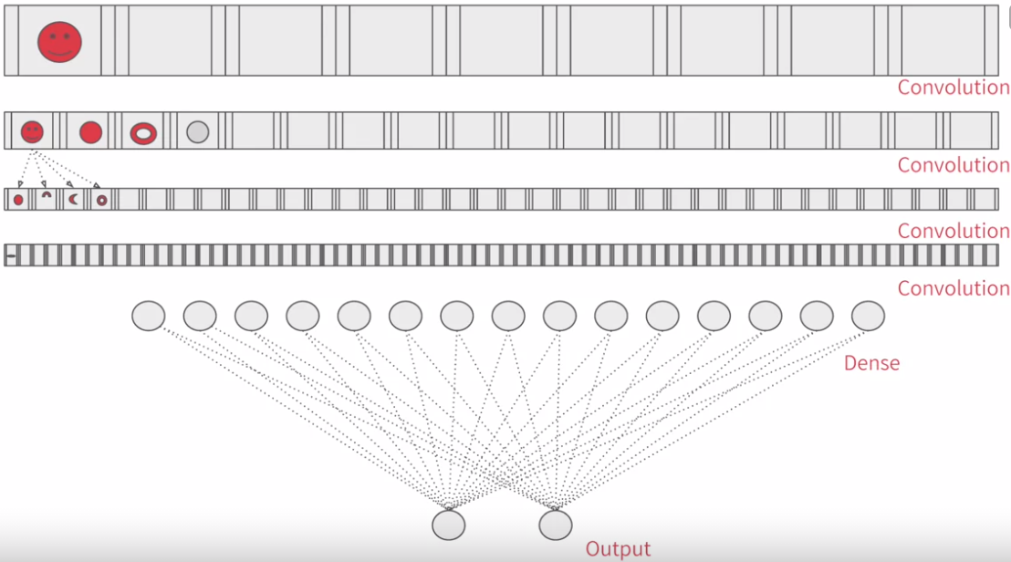

* So for example, if you visualize your model like this with a series of convolutional layers before dense layer leads your output layer, you feed your data into the top layer, the network learns the convolutions that identify the features in your data and all that.
* But consider somebody else's model, perhaps one that's far more sophisticated than yours, trained on a lot more data.
  + - 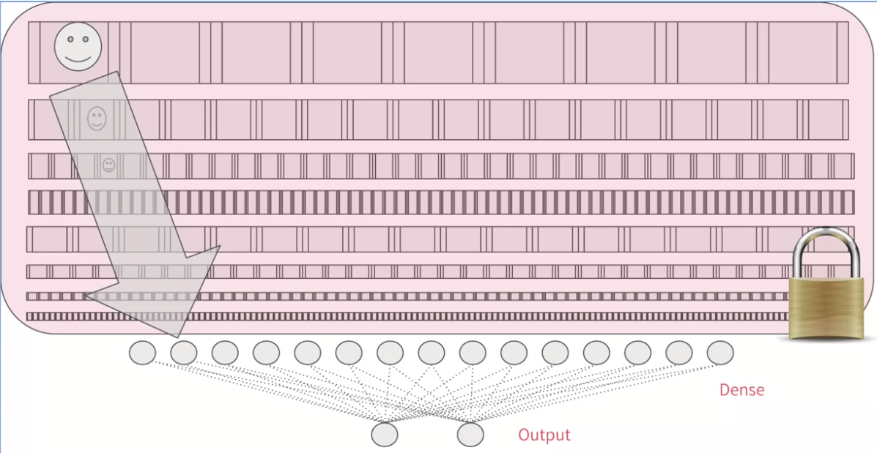
* They have convolutional layers and they're here intact with features that have already been learned.
* So you can lock them instead of retraining them on your data, and have those just extract the features from your data using the convolutions that they've already learned.
* Then you can take a model that has been trained on a very large datasets and use the convolutions that it learned when classifying its data.
* If you recall how convolutions are created and used to identify particular features, and the journey of a feature through the network, it makes sense to just use those, and then retrain the dense layers from that model with your data.

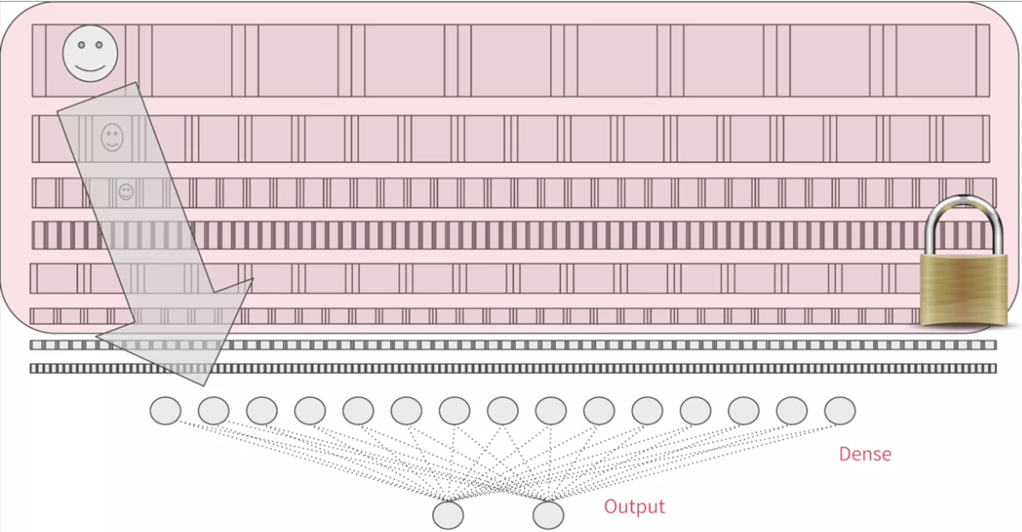

* Of course, well, it's typical that you might lock all the convolutions. You don't have to.
* You can choose to retrain some of the lower ones too because they may be too specialized for the images at hand.
* It takes some trial and error to discover the right combination.
* So let's take a well-trained state of the art model.
* There's one called Inception. This has been pre-trained on a dataset from ImageNet, which has 1.4 million images in a 1000 different classes.

(Have a look at the website – [here](https://arxiv.org/abs/1512.00567))

**Now that we've seen the concepts behind transfer learning, let's dig in and take a look at how to do it for ourselves with TensorFlow and Keras.**

**Open the notebook -** [https://colab.research.google.com/github/lmoroney/dlaicourse/blob/master/Course%202%20-%20Part%206%20-%20Lesson%203%20-%20Notebook.ipynb](https://colab.research.google.com/github/lmoroney/dlaicourse/blob/master/Course%202%20-%20Part%206%20-%20Lesson%203%20-%20Notebook.ipynb" \t "_blank)

**For more on how to freeze/lock layers, explore the documentation, which includes an example using MobileNet architecture:**<https://www.tensorflow.org/tutorials/images/transfer_learning>

#### Coding transfer learning from the inception mode

* So let's take a look at how we would achieve this in code.
* We'll start with the inputs.

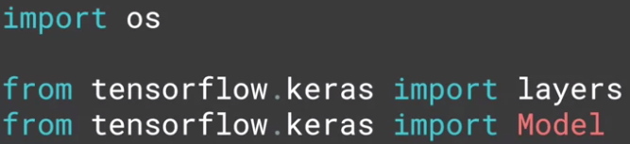

* In particular, we'll be using the keras layers API, to pick at the layers, and to understand which ones we want to use, and which ones we want to retrain.

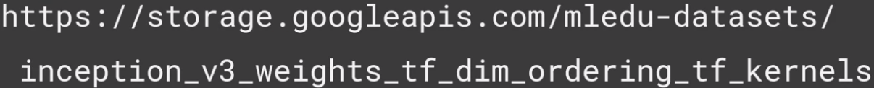

* A copy of the pretrained weights for the inception neural network is saved at this URL.
* Think of this as a snapshot of the model after being trained.
* It's the parameters that can then get loaded into the skeleton of the model, to turn it back into a trained model.

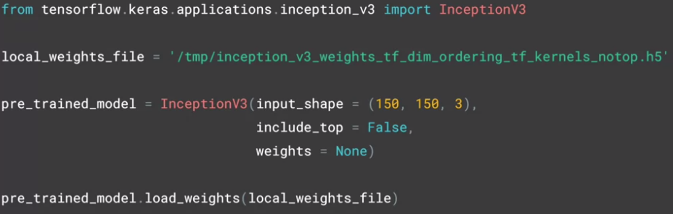

* So now if we want to use inception, it's fortunate that keras has the model definition built in.
* So you instantiate that with the desired input shape for your data, and specify that you don't want to use the built-in weights, but the snapshot that you've just downloaded.
* The inception V3 has a fully-connected layer at the top.
* So by setting include\_top to false, you're specifying that you want to ignore this and get straight to the convolutions.
* Now that I have my pretrained model instantiated, I can iterate through its layers and lock them, saying that they're not going to be trainable with this code.



* You can then print a summary of your pretrained model with this code but be prepared, it's huge.

#### Coding your own model with transferred features

* All of the layers have names, so you can look up the name of the last layer that you want to use.

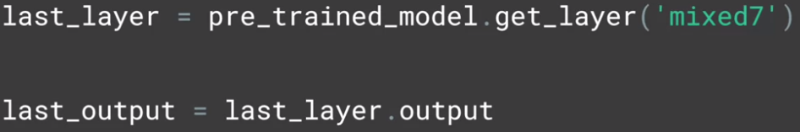

* If you inspect the summary, you'll see that the bottom layers have convolved to 3 by 3.
* But I want to use something with a little more information.
* So I moved up the model description to find mixed7, which is the output of a lot of convolution that are 7 by 7.

(You don't have to use this layer and is fun to experiment with others.)

* But with this code, I'm going to grab that layer from inception and take it to output.

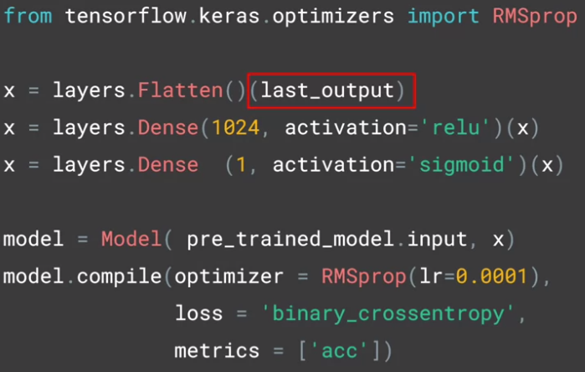

* So now we'll define our new model, taking the output from the inception model's mixed7 layer, which we had called last\_output.
* This should look exactly like the dense models that you created way back at the start of this course.
* The code is a little different, but this is just a different way of using the layers API.
* You start by flattening the input, which just happens to be the output from inception.
* And then add a Dense hidden layer.
* And then your output layer which has just one neuron activated by a sigmoid to classify between two items.
* You can then create a model using the Model abstract class.
* And passing at the input and the layers definition that you've just created.
* And then you compile it as before with an optimizer and a loss function and the metrics that you want to collect.

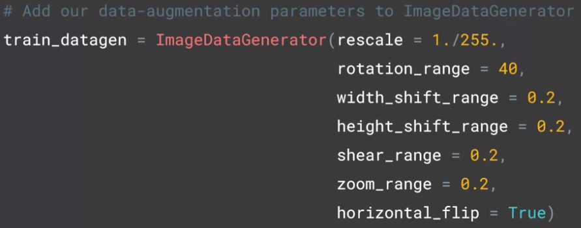

* As before you're going to augment the images with the image generator.

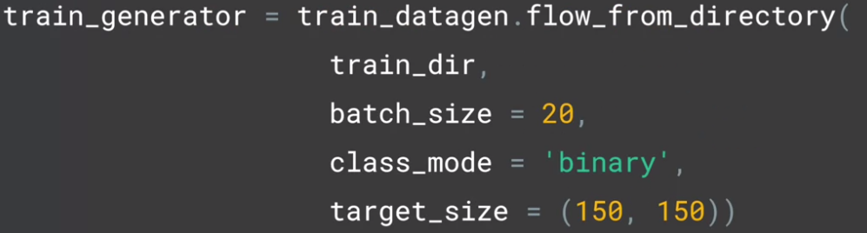

* Then, as before, we can get our training data from the generator by flowing from the specified directory and going through all the augmentations.

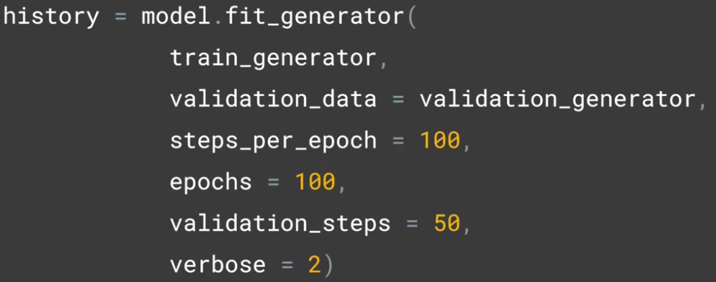

* And now we can train as before with model.fit\_generator.
* I'm going to run it for 100 epochs.
* What's interesting if you do this, is that you end up with another but a different overfitting situation.
* Here is the graph of the accuracy of training versus validation.

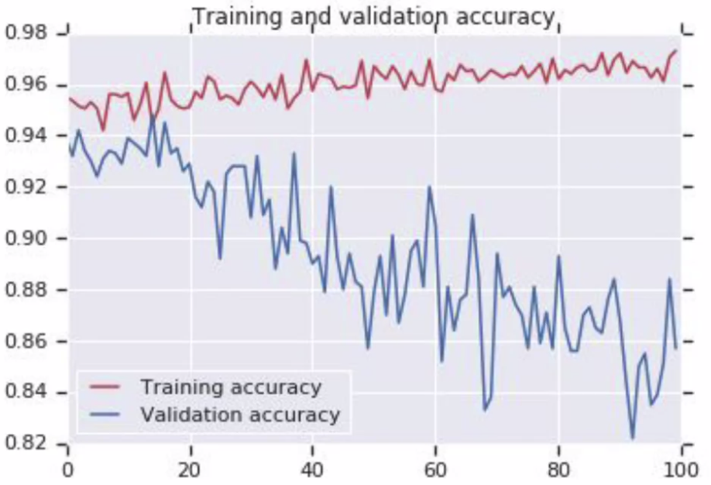

* As you can see, while it started out well, the validation is diverging away from the training in a really bad way. So, how do we fix this?
* We'll take a look at that in the next lesson.

## Using dropouts!

Another useful tool to explore at this point is the Dropout.

The idea behind Dropouts is that they remove a random number of neurons in your neural network. This works very well for two reasons: The first is that neighbouring neurons often end up with similar weights, which can lead to overfitting, so dropping some out at random can remove this. The second is that often a neuron can over-weigh the input from a neuron in the previous layer, and can over specialize as a result. Thus, dropping out can break the neural network out of this potential bad habit!

Check out Andrew's terrific video explaining dropouts here: <https://www.youtube.com/watch?v=ARq74QuavAo>

#### Exploring dropouts

* Now here's the accuracy of our training set versus our validation set over 100 epochs.



* There's another layer take in Keras called a dropout.

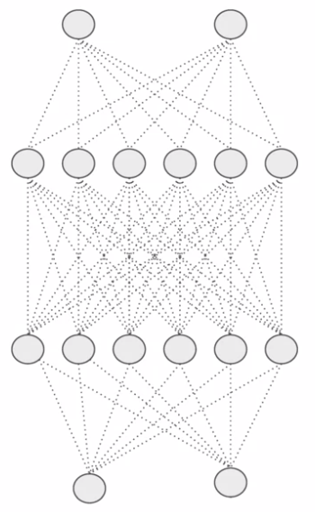 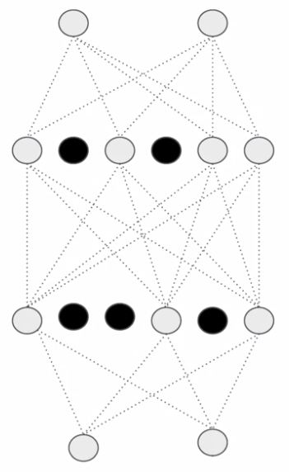

Before using dropouts After using dropouts

* And the idea behind the dropout is that layers in a neural network can sometimes end up having similar weights and possible impact each other leading to over-fitting.
* With a big complex model like this, that's a risk.
* So imagine the dense layers can look a little bit like this.(Before using dropouts)
* By dropping some out, we make it look like this.(After using dropouts)
* And that has the effect of neighbours not affecting each other too much and potentially removing overfitting.
* So how do we achieve this in code? Well, here's our model definition from earlier.

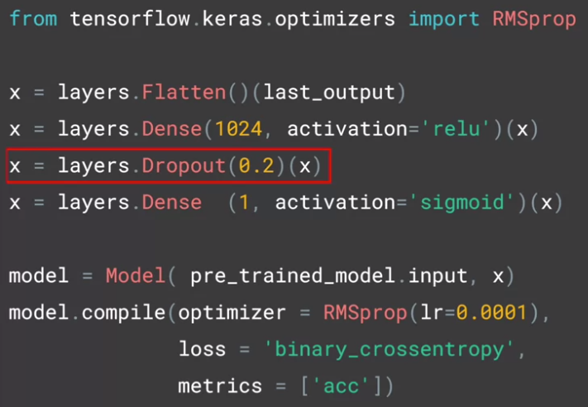

* And here's where we add the dropout.
* The parameter is between 0 and 1 and it's the fraction of units to drop.
* In this case, we're dropping out 20% of our neurons.
* For comparison, here's the chart of training against accuracy from before the dropout was added.
* When you see validation diverging away from the training like this over time, it's actually a great candidate to try using a dropout.

 

* And here's the impact of the dropout. You can see that it's very significant.

Note: If the dropout rate is set too high, then the network would lose specialization to the effect that it would be inefficient or ineffective at learning, driving accuracy down.

## Applying Transfer Learning to Cats v Dogs

Now that we've explored transfer learning, and taken a look at regularization using dropouts, let's step through the scenario for Cats vs Dogs in this [notebook](https://colab.research.google.com/github/lmoroney/dlaicourse/blob/master/Course%202%20-%20Part%206%20-%20Lesson%203%20-%20Notebook.ipynb) next.

#### Moving from binary to multi-class classification

* In the last few lessons, you've been building a binary classifier.
* One which detects two different types of objects, horse or human, cat or dog, that type of thing.
* In this lesson, we'll take a look at how we can extend that for multiple classes.
* Remember when we were classifying horses or human, we had a file structure like this. There were subdirectories for each class, where in this case we only had two.
* The first thing that you'll need to do is replicate this for multiple classes like this.
* It's very similar and here you can see that both the training and validation have three subdirectories.

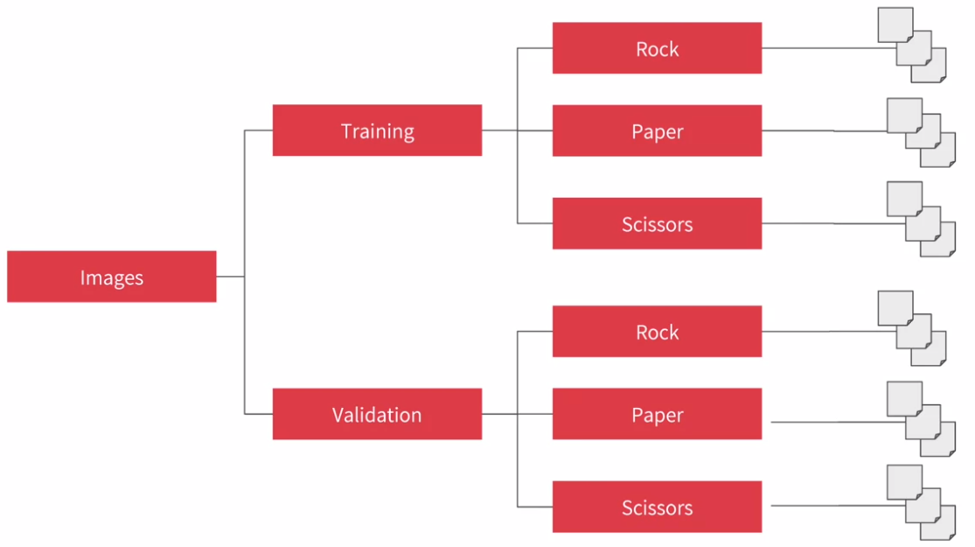

* One for Rock, one for Paper, and one for Scissors.
* In these, we can put training and validation images for Rock, Paper, and Scissors.

## Introducing the Rock-Paper-Scissors dataset

<http://www.laurencemoroney.com/rock-paper-scissors-dataset/>

Rock Paper Scissors is a dataset containing 2,892 images of diverse hands in Rock/Paper/Scissors poses. It is licensed [CC By 2.0](https://creativecommons.org/licenses/by/2.0/) and available for all purposes, but it’s intent is primarily for learning and research.

Rock Paper Scissors contains images from a variety of different hands,  from different races, ages and genders, posed into Rock / Paper or Scissors and labelled as such. You can download the [training set here](https://storage.googleapis.com/laurencemoroney-blog.appspot.com/rps.zip), and the [test set here](https://storage.googleapis.com/laurencemoroney-blog.appspot.com/rps-test-set.zip). These images have all been generated using CGI techniques as an experiment in determining if a CGI-based dataset can be used for classification against real images. I also generated a few images that you can use for predictions. You can find them [here](https://storage.googleapis.com/laurencemoroney-blog.appspot.com/rps-validation.zip). Note that all of this data is posed against a white background. Each image is 300×300 pixels in 24-bit colour

#### Explore multi-class with Rock Paper Scissors dataset

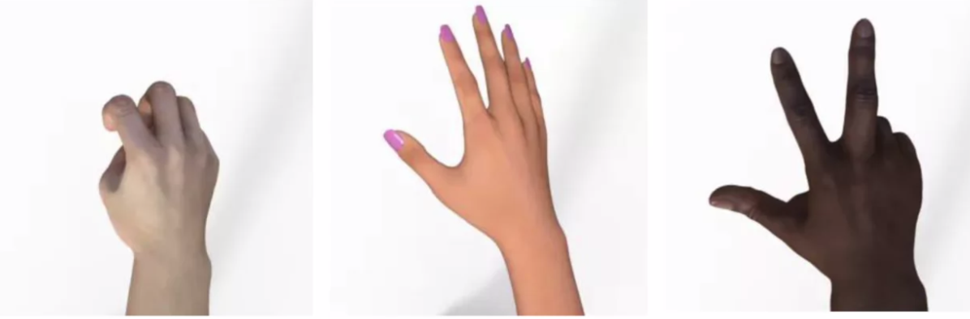

* They've all been generated using CGI with a diverse array of models, male and female, and lots of different skin tones, and here's some examples.

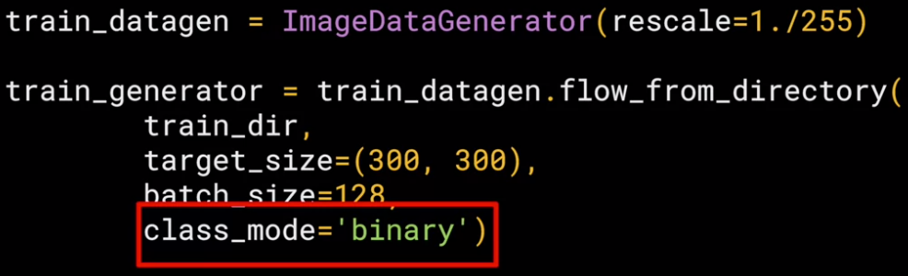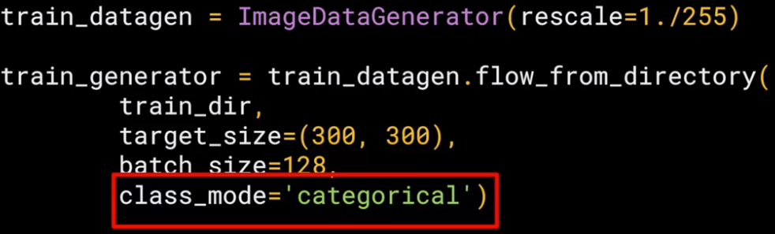

* Once your directory is set up, you need to set up your image generator.
* Earlier class mode was set to binary.
* For multiple classes, you'll have to change this to categorical like this.
* The next change comes in your model definition where you'll need to change the output layer.
* For a binary classifier, it was more efficient for you to just have ***one neuron*** and use a ***sigmoid*** function to activate it.
* This meant that it would output close to zero for one class and close to one for the other.

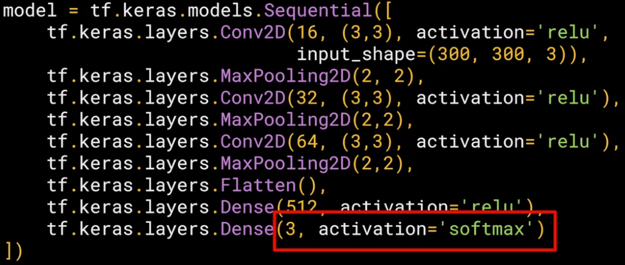

* Now, that doesn't fit for multi-class, so we need to change it, but it's pretty simple.
* Now, we have an output layer that has three neurons, one for each of the classes rock, paper, and scissors, and it's activated by softmax which turns all the values into probabilities that will sum up to one.
* So what does that really mean?

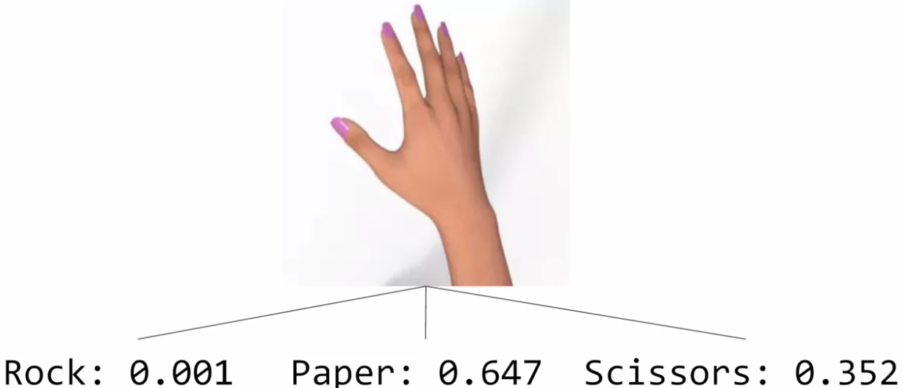

* Consider a hand like this one.
* It's most likely a paper, but because she has her first two fingers open, and the rest joined, it could also be mistaken as scissors.
* The output of a neural network with three neurons and a softmax would reflect that, and maybe look like this with a very low probability of rock, a really high one for paper, and a decent one for scissors.
* All three probabilities would still add up to one.
* The final change then comes when you compile your network.

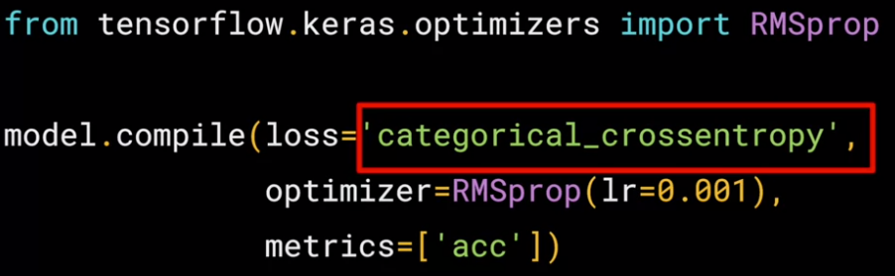

* If you recall with the earlier examples, your loss function was binary cross entropy.
* Now, you'll change it's a categorical cross entropy like this.
* There are other categorical loss functions including sparse categorical, cross entropy that you used in the fashion example, and you can of course also use those.
* I ran this for 100 epochs, and I got this chart, it shows the training hits a max at about 25 epochs.

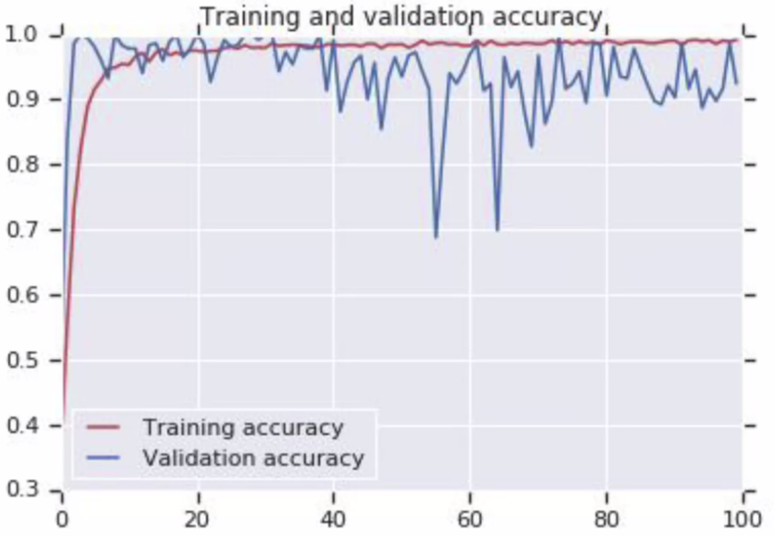

* So I'd recommend just using not many, and that's all really that you have to do.

## Check out the code!

Now that you've explored the data, and seen how the code can be modified from a binary class classifier to a multi class one, let's take a look at the [notebook](https://colab.research.google.com/github/lmoroney/dlaicourse/blob/master/Course%202%20-%20Part%208%20-%20Lesson%202%20-%20Notebook%20(RockPaperScissors).ipynb) that implements that for us!